Keywords

Place keywords here

Summary

Place summary here

References

Place references here

|  |  |  |  |  |  |  |  |
| --- | --- | --- | --- | --- | --- | --- | --- |
| Version | Date | Author | Initials | Review | Initials | Approval | Initials |
| 0.2 | dec. 2012 | B. Kuijper |  | J. Stijnen |  |  |  |
|  |  | M.T. Duits |  |  |  |  |  |
|  |  | R.G. Kamp |  |  |  |  |  |

|  |
| --- |
| State  draft  This is a draft report, intended for discussion purposes only. No part of this report may be relied upon by either principals or third parties. |

Contents

1 Introduction 1

2 Test series 3

2.1 Basic test series for each cross section 3

2.2 Output in general 4

2.3 Additional test series cross section 1 5

2.4 Additional test series cross section 2 6

2.5 Additional test series cross section 3 7

2.6 Additional test series cross section 4 8

2.7 Additional test series cross section 5 9

2.8 Additional test series cross section 6 10

2.9 Additional test series cross section 7 11

2.10 Additional test series cross section 8 12

3 Test results 13

3.1 Basic test series for each cross section 13

3.2 Additional test series for each cross section 14

4 Conclusions and recommendations 19

List of figures

Figure 2‑1: Example for the output of the test series 4

Figure 2‑2: Geometry for cross section nr. 1 5

Figure 2‑3: Geometry for cross section nr. 2 6

Figure 2‑4: Geometry for cross section nr. 3 7

Figure 2‑5: Geometry for cross section nr. 4 8

Figure 2‑6: Geometry for cross section nr. 5 9

Figure 2‑7: Geometry for cross section nr. 6 10

Figure 2‑8: Geometry for cross section nr. 7 11

Figure 2‑9: Geometry for cross section nr. 8 12

Figure 3‑1: Dimensionless overtopping discharge for breaking (Qb) and non-breaking (Qn) waves, cross section 3, test series 1 13

Figure 3‑2: Reduction factor berms, cross section 7, test series 3 14

Figure 3‑3: Representative slope (tanAlpha), breaker parameter (ksi0) and influence factor roughness (gammaF), cross section 3, test series 19 15

Figure 3‑4: Influence factor roughness, cross section 7, test series 11 17

List of tables

Table 2‑1: Overview of basic values for test series 3

Table 2‑2: Basic test series for each cross section 4

Table 2‑3: Additional test series cross section nr. 1 5

Table 2‑4: Additional test series cross section nr. 2 6

Table 2‑5: Additional test series cross section nr. 3 7

Table 2‑6: Additional test series cross section nr. 4 8

Table 2‑7: Additional test series cross section nr. 5 9

Table 2‑8: Additional test series cross section nr. 6 10

Table 2‑9: Additional test series cross section nr. 7 11

Table 2‑10: Additional test series cross section nr. 8 12

# Introduction

This document describes the test results for the RTO overtopping module. These tests consist of test series in which certain input parameters, for example the wave height or segment slope, are varied to determine their effect on the output, namely: the 2% wave run-up and the wave overtopping discharge.

Tests are carried out for different types of cross sections of flood defences, with increasing complexity, beginning with a cross section with only one segment, then a cross section with two segments, and so on, up to a cross section with five segments, consisting of both slope segments and berms.

For each cross section a number of test series is constructed. First, a number of basic test series, in which the water level and wave parameters are varied. Followed by a number of cross section specific tests, in which the slope and roughness of the different segments are varied.

Chapter 2 describes the different cross sections and test series. Chapter 3 gives an overview of the test results. The test results are not analysed in detail but overall conclusions of trends and anomalies are reported. Figures with the output of the RTO overtopping module (2% wave run-up and the wave overtopping discharge) for all cross sections and test series are given in the Appendix.

The conclusions and recommendations are given in chapter 4.

# Test series

Tests are carried out for different types of cross sections, with increasing complexity, beginning with a cross section with only one segment, then a cross section with two segments, and so on, up to a cross section with five segments, consisting of both slope segments and berms.

For each cross section a number of test series is constructed. First, a number of basic test, in which the water level and wave parameters are varied. Followed by a number of cross section specific tests, in which the slope and roughness of the different segments is varied. This chapter describes the different cross sections and test series.

## Basic test series for each cross section

The overtopping module has four input parameters: water level, wave height, wave period (spectral wave period) and the wave direction. In practice the wave height and the wave period are correlated. For instance: a large wave height in combination with a short wave period isn't very likely. This combination gives steep waves. The steepness of a wave can be computed by

 (2.1)

with

*So* the wave steepness [-]

*Hm*0 the wave height [m]

*Tm*-1*,*0 the spectral wave period [s]

*g* the gravity constant [m/s2].

In practice, the value of the wave steepness is limited. To prevent computations with non-necessary combinations of wave heights and wave periods test series will have input that consists of water levels, wave heights, wave steepness and wave directions. The basic values are presented in Table 2‑1. For the wave direction two values are chosen. One value isn't enough because of the additional reductions for wave directions larger than 80 degrees. These also have to be tested.

|  |  |
| --- | --- |
| Input value | Basic value |
| Water level (m+NAP) | 3.0 |
| Wave height (m) | 2.0 |
| Wave steepness (-) | 0.04 |
| Wave direction  (degrees w.r.t. dike normal) | 0.0 85.0 |

Table 2‑1: Overview of basic values for test series

Using the basic values from Table 2‑1 the spectral wave period in the basic situation – with use of formula (2.1) - is equal to 5.66 sec. Rewriting formula (2.1) can help to compute the spectral wave period from the wave height and the wave steepness:

. (2.2)

Starting with the basic values from Table 2‑1 seven test series are composed in which each time only one value is varied. The seven test series are presented in Table 2‑2. These are the basic test series for each cross section.

|  |  |  |  |  |
| --- | --- | --- | --- | --- |
|  | Water level (m+NAP) | Wave height (m) | Wave steepness (-) | Wave direction (º w.r.t. dike normal) |
| Test series 1 | -2 to 6 (step 0.01) | 2.0 | 0.04 | 0.0 |
| Test series 2 | 3.0 | 2.0 | 0.04 | 85.0 |
| Test series 3 | 3.0 | 0 to 5 (step 0.01) | 0.04 | 0.0 |
| Test series 4 | 3.0 | 0 to 5 (step 0.01) | 0.04 | 85.0 |
| Test series 5 | 3.0 | 2.0 | 0.001 to 0.07 (step 0.001) | 0.0 |
| Test series 6 | 3.0 | 2.0 | 0.001 to 0.07 (step 0.001) | 85.0 |
| Test series 7 | 3.0 | 2.0 | 0.04 | 0 to 180 (step 1) |

Table 2‑2: Basic test series for each cross section

In the following sections additional tests are presented for each cross section, in which the slope and roughness of the different segments is varied. These cross section specific test series are combined with the water level, wave height and wave steepness from Table 2‑1.

## Output in general

Two output parameters are examined: the wave run-up (z2%) and the overtopping discharge. The output is presented by figures with the varied parameter on the x-axis. An example is presented below for the slope of the cross section. Notice that the wave run-up in the figures is the level of the 2% wave run-up, that is: the local water level plus the wave run-up in meters. The latter is the actual output of the RTO overtopping module.

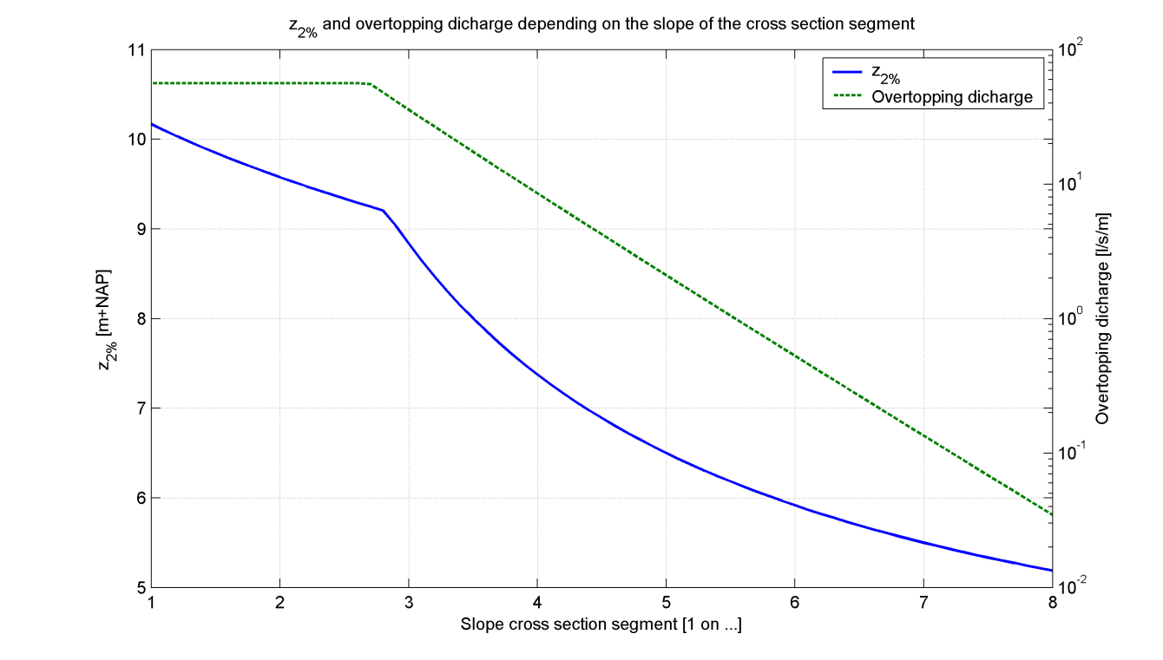

Figure 2‑1: Example for the output of the test series

## Additional test series cross section 1



|  |  |  |
| --- | --- | --- |
| x-coordinates | 0 | 8 |
| y-coordinates | -2 | 6 |
| slope | 1:1 |  |
| Roughness coefficient [-] | 1.0 |  |

Figure 2‑2: Geometry for cross section nr. 1

|  |  |  |  |
| --- | --- | --- | --- |
|  | Parameter to vary in the test series | Variation range | Wave direction (º w.r.t. dike normal) |
| Test series 8 | slope (-) | 1:1, 1:1.1, 1:1.2, …, 1:7.9, 1:8 | 0.0 |
| Test series 9 | slope (-) | 1:1, 1:1.1, 1:1.2, …, 1:7.9, 1:8 | 85.0 |
| Test series 10 | roughness coefficient (-) | 0.5 to 1.0 (step 0.01) | 0.0 |
| Test series 11 | roughness coefficient (-) | 0.5 to 1.0 (step 0.01) | 85.0 |

Table 2‑3: Additional test series cross section nr. 1

## Additional test series cross section 2



|  |  |  |  |
| --- | --- | --- | --- |
| x-coordinates | 0 | 48 | 50 |
| y-coordinates | -2 | 4 | 6 |
| slope | 1:8 | 1:1 |  |
| Roughness coefficient [-] | 1.0 | 1.0 |  |

Figure 2‑3: Geometry for cross section nr. 2

|  |  |  |  |
| --- | --- | --- | --- |
|  | Parameter to vary in the test series | Variation range | Wave direction (º w.r.t. dike normal) |
| Test series 8 | slope lower segment (-) | 1:1, 1:1.1, …, 1:7.9, 1:8 | 0.0 |
| Test series 9 | slope lower segment (-) | 1:1, 1:1.1, …, 1:7.9, 1:8 | 85.0 |
| Test series 10 | slope upper segment (-) | 1:1, 1:1.1, …, 1:7.9, 1:8 | 0.0 |
| Test series 11 | slope upper segment (-) | 1:1, 1:1.1, …, 1:7.9, 1:8 | 85.0 |
| Test series 12 | buckling point (m+NAP) | -1.75 to 4 (step 0.125) | 0.0 |
| Test series 13 | buckling point (m+NAP) | -1.75 to 4 (step 0.125) | 85.0 |
| Test series 14 | roughness both segments (-) | 0.5 to 1.0 (step 0.01) | 0.0 |
| Test series 15 | roughness both segments (-) | 0.5 to 1.0 (step 0.01) | 85.0 |
| Test series 16 | roughness lower segment (-) | 0.5 to 1.0 (step 0.01) | 0.0 |
| Test series 17 | roughness lower segment (-) | 0.5 to 1.0 (step 0.01) | 85.0 |
| Test series 18 | roughness upper segment (-) | 0.5 to 1.0 (step 0.01) | 0.0 |
| Test series 19 | roughness upper segment (-) | 0.5 to 1.0 (step 0.01) | 85.0 |

Table 2‑4: Additional test series cross section nr. 2

## Additional test series cross section 3



|  |  |  |  |
| --- | --- | --- | --- |
| x-coordinates | 0 | 6 | 22 |
| y-coordinates | -2 | 4 | 6 |
| slope | 1:1 | 1:8 |  |
| Roughness coefficient [-] | 1.0 | 1.0 |  |

Figure 2‑4: Geometry for cross section nr. 3

|  |  |  |  |
| --- | --- | --- | --- |
|  | Parameter to vary in the test series | Variation range | Wave direction (º w.r.t. dike normal) |
| Test series 8 | slope lower segment (-) | 1:1, 1:1.1, …, 1:7.9, 1:8 | 0.0 |
| Test series 9 | slope lower segment (-) | 1:1, 1:1.1, …, 1:7.9, 1:8 | 85.0 |
| Test series 10 | slope upper segment (-) | 1:1, 1:1.1, …, 1:7.9, 1:8 | 0.0 |
| Test series 11 | slope upper segment (-) | 1:1, 1:1.1, …, 1:7.9, 1:8 | 85.0 |
| Test series 12 | buckling point (m+NAP) | 0 to 4 (step 0.1) | 0.0 |
| Test series 13 | buckling point (m+NAP) | 0 to 4 (step 0.1) | 85.0 |
| Test series 14 | roughness both segments (-) | 0.5 to 1.0 (step 0.01) | 0.0 |
| Test series 15 | roughness both segments (-) | 0.5 to 1.0 (step 0.01) | 85.0 |
| Test series 16 | roughness lower segment (-) | 0.5 to 1.0 (step 0.01) | 0.0 |
| Test series 17 | roughness lower segment (-) | 0.5 to 1.0 (step 0.01) | 85.0 |
| Test series 18 | roughness upper segment (-) | 0.5 to 1.0 (step 0.01) | 0.0 |
| Test series 19 | roughness upper segment (-) | 0.5 to 1.0 (step 0.01) | 85.0 |

Table 2‑5: Additional test series cross section nr. 3

## Additional test series cross section 4



|  |  |  |  |  |
| --- | --- | --- | --- | --- |
| x-coordinates | 0 | 24 | 28 | 34 |
| y-coordinates | -2 | 4 | 4 | 6 |
| slope | 1:4 | 0 | 1:3 |  |
| Roughness coefficient [-] | 1.0 | 1.0 | 1.0 |  |

Figure 2‑5: Geometry for cross section nr. 4

|  |  |  |  |
| --- | --- | --- | --- |
|  | Parameter to vary in the test series | Variation range | Wave direction (º w.r.t. dike normal) |
| Test series 8 | slope berm segment (-) | 1:1, 1:1.1, …, 1:7.9, 1:8 | 0.0 |
| Test series 9 | slope berm segment (-) | 1:1, 1:1.1, …, 1:7.9, 1:8 | 85.0 |
| Test series 10 | slope other segments (-) | 1:1, 1:1.1, …, 1:7.9, 1:8 | 0.0 |
| Test series 11 | slope other segments (-) | 1:1, 1:1.1, …, 1:7.9, 1:8 | 85.0 |
| Test series 12 | length berm segment (m) | 2 to 20 (step 1) | 0.0 |
| Test series 13 | length berm segment (m) | 2 to 20 (step 1) | 85.0 |
| Test series 14 | roughness berm segment (-) | 0.5 to 1.0 (step 0.01) | 0.0 |
| Test series 15 | roughness berm segment (-) | 0.5 to 1.0 (step 0.01) | 85.0 |
| Test series 16 | roughness other segments (-) | 0.5 to 1.0 (step 0.01) | 0.0 |
| Test series 17 | roughness other segments (-) | 0.5 to 1.0 (step 0.01) | 85.0 |

Table 2‑6: Additional test series cross section nr. 4

## Additional test series cross section 5



|  |  |  |  |  |  |
| --- | --- | --- | --- | --- | --- |
| x-coordinates | 0 | 23 | 27 | 31 | 37 |
| y-coordinates | -2 | 3.75 | 4 | 4 | 6 |
| slope | 1:4 | 1:16 | 0 | 1:3 |  |
| Roughness coefficient [-] | 1.0 | 1.0 | 1.0 | 1.0 |  |

Figure 2‑6: Geometry for cross section nr. 5

|  |  |  |  |
| --- | --- | --- | --- |
|  | Parameter to vary in the test series | Variation range | Wave direction (º w.r.t. dike normal) |
| Test series 8 | slope first berm segment (-) | 1:1, 1:1.1, …, 1:7.9, 1:8 | 0.0 |
| Test series 9 | slope first berm segment (-) | 1:1, 1:1.1, …, 1:7.9, 1:8 | 85.0 |
| Test series 10 | slope first + last segment (-) | 1:1, 1:1.1, …, 1:7.9, 1:8 | 0.0 |
| Test series 11 | slope first + last segment (-) | 1:1, 1:1.1, …, 1:7.9, 1:8 | 85.0 |
| Test series 12 | roughness first berm (-) | 0.5 to 1.0 (step 0.01) | 0.0 |
| Test series 13 | roughness first berm (-) | 0.5 to 1.0 (step 0.01) | 85.0 |
| Test series 14 | roughness second berm (-) | 0.5 to 1.0 (step 0.01) | 0.0 |
| Test series 15 | roughness second berm (-) | 0.5 to 1.0 (step 0.01) | 85.0 |
| Test series 16 | roughness lower segment and second berm segment (-) | 0.5 to 1.0 (step 0.01) | 0.0 |
| Test series 17 | roughness lower segment and second berm segment (-) | 0.5 to 1.0 (step 0.01) | 85.0 |
| Test series 16 | roughness first berm segment and upper segment (-) | 0.5 to 1.0 (step 0.01) | 0.0 |
| Test series 17 | roughness first berm segment and upper segment (-) | 0.5 to 1.0 (step 0.01) | 85.0 |

Table 2‑7: Additional test series cross section nr. 5

## Additional test series cross section 6



|  |  |  |  |  |  |
| --- | --- | --- | --- | --- | --- |
| x-coordinates | 0 | 15 | 19 | 23 | 35 |
| y-coordinates | -2 | 1.75 | 2 | 2 | 6 |
| slope | 1:4 | 1:16 | 0 | 1:3 |  |
| Roughness coefficient [-] | 1.0 | 1.0 | 1.0 | 1.0 |  |

Figure 2‑7: Geometry for cross section nr. 6

|  |  |  |  |
| --- | --- | --- | --- |
|  | Parameter to vary in the test series | Variation range | Wave direction (º w.r.t. dike normal) |
| Test series 8 | slope second berm segment (-) | 1:1, 1:1.1, …, 1:7.9, 1:8 | 0.0 |
| Test series 9 | slope second berm segment (-) | 1:1, 1:1.1, …, 1:7.9, 1:8 | 85.0 |
| Test series 10 | slope first + last segment (-) | 1:1, 1:1.1, …, 1:7.9, 1:8 | 0.0 |
| Test series 11 | slope first + last segment (-) | 1:1, 1:1.1, …, 1:7.9, 1:8 | 85.0 |
| Test series 12 | roughness first berm (-) | 0.5 to 1.0 (step 0.01) | 0.0 |
| Test series 13 | roughness first berm (-) | 0.5 to 1.0 (step 0.01) | 85.0 |
| Test series 14 | roughness second berm (-) | 0.5 to 1.0 (step 0.01) | 0.0 |
| Test series 15 | roughness second berm (-) | 0.5 to 1.0 (step 0.01) | 85.0 |
| Test series 16 | roughness lower segment and second berm segment (-) | 0.5 to 1.0 (step 0.01) | 0.0 |
| Test series 17 | roughness lower segment and second berm segment (-) | 0.5 to 1.0 (step 0.01) | 85.0 |
| Test series 16 | roughness first berm segment and upper segment (-) | 0.5 to 1.0 (step 0.01) | 0.0 |
| Test series 17 | roughness first berm segment and upper segment (-) | 0.5 to 1.0 (step 0.01) | 85.0 |

Table 2‑8: Additional test series cross section nr. 6

## Additional test series cross section 7



|  |  |  |  |  |  |  |
| --- | --- | --- | --- | --- | --- | --- |
| x-coordinates | 0 | 16 | 20 | 26 | 30 | 36 |
| y-coordinates | -2 | 2 | 2 | 4 | 4 | 6 |
| slope | 1:4 | 0 | 1:3 | 0 | 1:3 |  |
| Roughness coefficient [-] | 1.0 | 1.0 | 1.0 | 1.0 | 1.0 |  |

Figure 2‑8: Geometry for cross section nr. 7

|  |  |  |  |
| --- | --- | --- | --- |
|  | Parameter to vary in the test series | Variation range | Wave direction (º w.r.t. dike normal) |
| Test series 8 | slope non-berm segments (-) | 1:1, 1:1.1, …, 1:7.9, 1:8 | 0.0 |
| Test series 9 | slope non-berm segments (-) | 1:1, 1:1.1, …, 1:7.9, 1:8 | 85.0 |
| Test series 10 | roughness berm segments (-) | 0.5 to 1.0 (step 0.01) | 0.0 |
| Test series 11 | roughness berm segments (-) | 0.5 to 1.0 (step 0.01) | 85.0 |
| Test series 12 | roughness other segments (-) | 0.5 to 1.0 (step 0.01) | 0.0 |
| Test series 13 | roughness other segments (-) | 0.5 to 1.0 (step 0.01) | 85.0 |

Table 2‑9: Additional test series cross section nr. 7

## Additional test series cross section 8



|  |  |  |  |  |  |  |
| --- | --- | --- | --- | --- | --- | --- |
| x-coordinates | 0 | 14 | 18 | 24 | 28 | 34 |
| y-coordinates | -2 | 1.5 | 1.75 | 3.75 | 4 | 6 |
| slope | 1:4 | 1:16 | 1:3 | 1:16 | 1:3 |  |
| Roughness coefficient [-] | 1.0 | 1.0 | 1.0 | 1.0 | 1.0 |  |

Figure 2‑9: Geometry for cross section nr. 8

|  |  |  |  |
| --- | --- | --- | --- |
|  | Parameter to vary in the test series | Variation range | Wave direction (º w.r.t. dike normal) |
| Test series 8 | slope non-berm segments (-) | 1:1, 1:1.1, …, 1:7.9, 1:8 | 0.0 |
| Test series 9 | slope non-berm segments (-) | 1:1, 1:1.1, …, 1:7.9, 1:8 | 85.0 |
| Test series 10 | roughness berm segments (-) | 0.5 to 1.0 (step 0.01) | 0.0 |
| Test series 11 | roughness berm segments (-) | 0.5 to 1.0 (step 0.01) | 85.0 |
| Test series 12 | roughness other segments (-) | 0.5 to 1.0 (step 0.01) | 0.0 |
| Test series 13 | roughness other segments (-) | 0.5 to 1.0 (step 0.01) | 85.0 |

Table 2‑10: Additional test series cross section nr. 8

# Test results

## Basic test series for each cross section

The expected results for the basic test series are as follows:

* If the water level increases the z2% and the overtopping discharge increase.
* If the wave height increases the z2% and the overtopping discharge increase.
* If the wave steepness increases the z2% and the overtopping discharge decrease.
* If the wave direction increases the z2% and the overtopping discharge decrease.

All basic test series fulfill these expectations, with the exception of cross section 3, where there is a minor decrease in overtopping discharge for some water levels (test series 1 and 2). This is due to the transition from the overtopping discharge for breaking to non-breaking waves, as explained below.

Cross section 3, test series 1 (and 2)

Figure 3‑1 shows the dimensionless overtopping discharge for both the breaking and non-breaking waves, for cross section 3, with varying water level (test series 1). The resulting overtopping discharge equals the minimum of these two values (multiplied by a factor depending on the wave height). For lower water levels this result is based on the overtopping discharge for non-breaking waves (Qn), but for water levels higher than about -0.35 m+NAP the result is based on the overtopping discharge for breaking waves (Qb). The latter does not always increase with increasing water levels, since it depends on the representative slope angle. For cross section 3 the representative slope angle decreases with increasing water levels, because the lower segment has a steeper slope than the upper segment.



Figure 3‑1: Dimensionless overtopping discharge for breaking (Qb) and non-breaking (Qn) waves, cross section 3, test series 1

Cross section 7 (and 8), test series 3 (and 4)

The test series for cross section 7 and cross section 8 show a remarkable jump in the z2% and overtopping discharge when the wave height increases (test series 3 and 4). This jump occurs for wave height (Hm0) equal to 2 m, and is a direct consequence of a jump in the reduction factor for berms, as shown in the figure below. The calculation of the reduction factor for berms uses the influence width of each berm, which (for each berm separately) is defined as the horizontal distance between the berm height minus one wave height and the berm height plus one wave height. For the berms in cross section 7 there is a jump in the influence width of each berm at Hm0 = 2 m, because that is exactly the point at which the width of the other berm is added to the influence width. So, in short: the jump in z2% occurs at a wave height of 2 m, since that is exactly the vertical distance between the two berms in this cross section.



Figure 3‑2: Reduction factor berms, cross section 7, test series 3

## Additional test series for each cross section

The expected results for the cross section specific test series are as follows:

* If the slope decreases the z2% and the overtopping discharge decrease.
* If the roughness coefficient decreases the z2% and the overtopping discharge decrease.
* If the length of a berm increases the z2% and the overtopping discharge decrease.
* If the level of a berm increases the z2% and the overtopping discharge decrease.

All additional test series fulfill these expectations, with the following exceptions:

* Cross section 2, test series 19
* Cross section 3, test series 19
* Cross section 6, test series 12-17
* Cross section 7, test series 11
* Cross section 7, test series 12

Cross section 2, test series 19

The wave run-up in this test series is constant for varying roughness of the upper segment. This is because in the calculation of the influence factor for roughness only a part of the cross section around the still water level is taken into account (depending on the wave run-up itself). In this case the still water level (3 m+NAP) in combination with the wave run-up leads to an influence factor for roughness that is only based on (part of) the lower segment. Since the roughness of this section is not varied in test series 19, the wave run-up is constant. As a result all parameters in the calculation of the overtopping discharge are also constant, and therefore also the overtopping discharge itself.

Cross section 3, test series 19

For this test series the overtopping discharge increases when the roughness coefficient decreases (for part of the test series). In this case, the overtopping discharge is completely determined by the overtopping discharge for breaking waves. When all other parameters are fixed, this discharge decreases when the roughness coefficient decreases. In this case however, also the breaker parameter changes and increases with the decreasing roughness coefficient (see Figure 3‑3). For small roughness coefficients, the increasing breaker parameter has a larger effect than the decreasing value of the roughness coefficient itself, which leads to larger overtopping discharges. The increasing breaker parameter is a side-effect of the decreasing roughness coefficient, since the wave run-up decreases and therefore the representative slope angle is more and more influenced by the steeper lower segment from cross section 3.



Figure 3‑3: Representative slope (tanAlpha), breaker parameter (ksi0) and influence factor roughness (gammaF), cross section 3, test series 19

Cross section 6, test series 12-17

The wave run-up and/or overtopping discharge in these test series are constant for varying roughness. For the test series 12, 14, and 16, with wave direction 0º (w.r.t. the dike normal) only the overtopping discharge is constant. For the test series 13, 15 and 17, with wave direction 85º (w.r.t. the dike normal) both the wave run-up and overtopping discharge are constant.

In the latter cases, the explanation is exactly the same as for cross section 2, test series 19 above: in the calculation of the influence factor for roughness only the roughness of the upper segment is used (due the combination of the still water level and the wave run-up itself), and since the roughness of this segment is not varied in the test series, the results are the same for all roughness coefficients.

For the test series 12, 14 and 16 the situation is more complex: the wave run-up changes, but the overtopping discharge is constant for varying roughness coefficients. This has to do with the iteration procedure in the calculation of the wave run-up. In this iteration procedure the influence factor for the roughness is calculated based on z2%,rough, the wave run-up in which the influence of the berm(s) is not yet taken into account. This value of the wave run-up is larger than the actual value of the wave run-up at the end of each iteration step, where the influence of the berm(s) is taken into account. Because of this, in the test series 12, 14 and 16 the influence factor for roughness based on z2%,rough varies, since part of the segment for which the roughness is varied is used in the calculation of the influence factor for roughness. For the calculation of the overtopping discharge however, the influence factor for roughness is based on the final value of the wave run-up (in which the influence of the berms is taken into account). Thereby only the upper segment is used in the calculation of the influence factor for roughness, and since the roughness of this segment is not varied in the test series, the overtopping discharge is the same for all roughness coefficients.

The argument above shows that for cross sections with one or more berms the influence factor for roughness that is used to calculate the wave run-up (based on z2%,rough) does not necessarily have to match with the influence factor for roughness that would be calculated using that same value for the wave run-up (z2%). The latter one is used in the calculation of the overtopping discharge. As a consequence, the influence factor for roughness that is used in the calculation of the wave run-up can differ from the influence factor that is used in the calculation of the overtopping discharge. It is questionable if this difference is desirable. There are basically two ways to prevent this:

1. Change the iteration procedure for the calculation of the wave run-up, such that the used influence factor for roughness matches the final value of the wave run-up.
2. Do not recalculate the influence factor for roughness before calculating the overtopping discharge.

Cross section 7, test series 11

For cross section 7, test series 11 there is a remarkable jump in the overtopping discharge from roughness coefficient 0.52 to roughness coefficient 0.53. For this test series the roughness coefficient in question is the roughness coefficient of the berms.

Further analysis shows that the same jump occurs in the influence factor for roughness (see Figure 3‑4). This is due to the fact that in for roughness coefficient 0.52 the wave run-up equals a little less than 2 m and therefore the influence factor for roughness is calculated based on the cross section between about 2.5 m+NAP and a little less than 4 m+NAP. For roughness coefficient 0.53 the wave run‑up equals a little more than 2 m and therefore the influence factor for roughness is calculated based on the cross section between about 2.5 m+NAP and a little more than 4 m+NAP. In the latter case the roughness coefficient on the second berm (at exactly 4 m+NAP) is also taken into account, in the first case not. The jump occurs because the berms in this cross section are horizontal, so the roughness on the berm is immediately taken into account for the complete berm width. This is exactly the reason why horizontal berms won’t be permitted in a real application of the overtopping module, but only for test purposes.



Figure 3‑4: Influence factor roughness, cross section 7, test series 11

Cross section 7, test series 12

For this test series a minor jump in the overtopping discharge occurs due to a larger jump in the wave run-up. The latter occurs because at this point the roughness coefficient of the lower berm is taken into account in the calculation of the influence factor for roughness. In this test series the roughness coefficient of the berms is 1 and the roughness coefficient of the other segments is varied. Therefore, the influence factor for the roughness becomes much closer to 1 when the roughness of the lower berm segment is taken into account, and as a result of that the wave run-up takes a higher value.

# Conclusions and recommendations

This document describes the test results for the RTO overtopping module. These tests consist of test series in which certain input parameters, for example the wave height or segment slope, are varied to determine the effect of these parameters on the output, namely: the 2% wave run-up and the wave overtopping discharge.

Correctness of the computation results is largely examined through visual inspection of the output figures (as presented in the Appendix). In cases where the output didn’t meet the expected behavior or where jumps in the graphs occurred, further analysis was used. These results are described in the previous chapter.

The test results are positive: in most test series the wave run-up and overtopping discharge followed expected behavior. For test series where this wasn’t the case, further analysis showed plausible explanations of the results and that they are indeed correct.

However, the tests also showed one possible shortcoming of the iteration procedure in the calculation of the wave run-up: the influence factors for berms and roughness that are used in the calculation of the wave run-up (z2%) do not necessarily have to match the influence factors that would be calculated based on that same value of the wave run-up.

Before the computation of the overtopping discharge these influence factors are recalculated using the final value of the wave run-up. As a consequence, the influence factors that are used in the calculation of the wave run-up can differ from the influence factors that are used in the calculation of the overtopping discharge. It is questionable if this difference is desirable. There are basically two ways to prevent this:

1. Change the iteration procedure for the calculation of the wave run-up, so that the used influence factors for berms and roughness match the final value of the wave run-up.
2. Do not recalculate the influence factors before calculating the overtopping discharge.

We recommend further analysis at this point, to determine whether or not the calculation of the wave run-up and overtopping discharge should be changed.

We recommend also a more precise comparison with PC-Overslag results. Additional testing should test the correctness physics of the results in addition to the visible inspection before implementing this module in Hydra-Ring.

**Appendix**

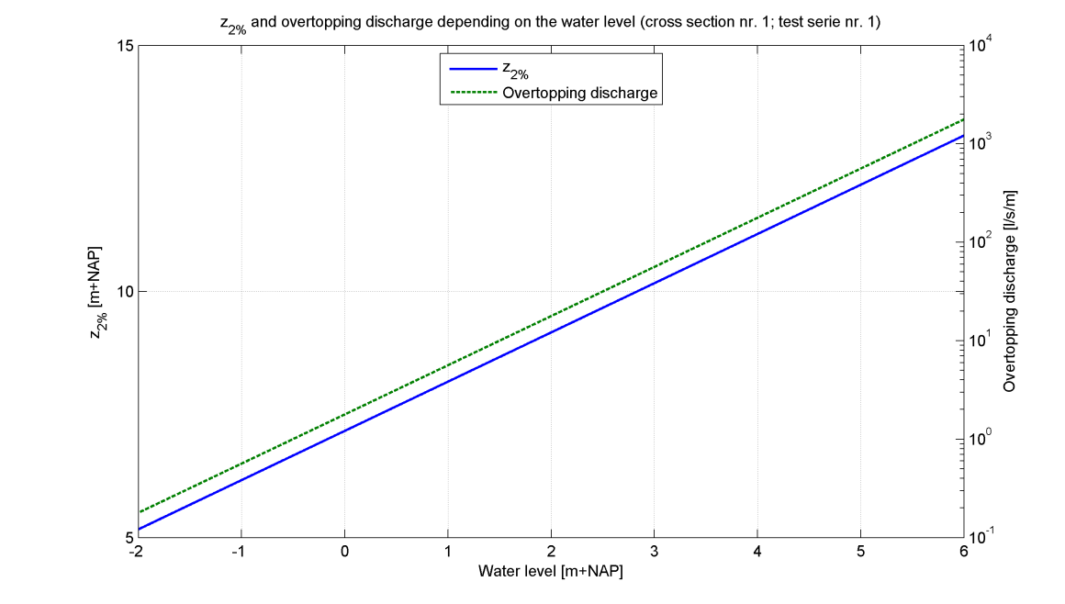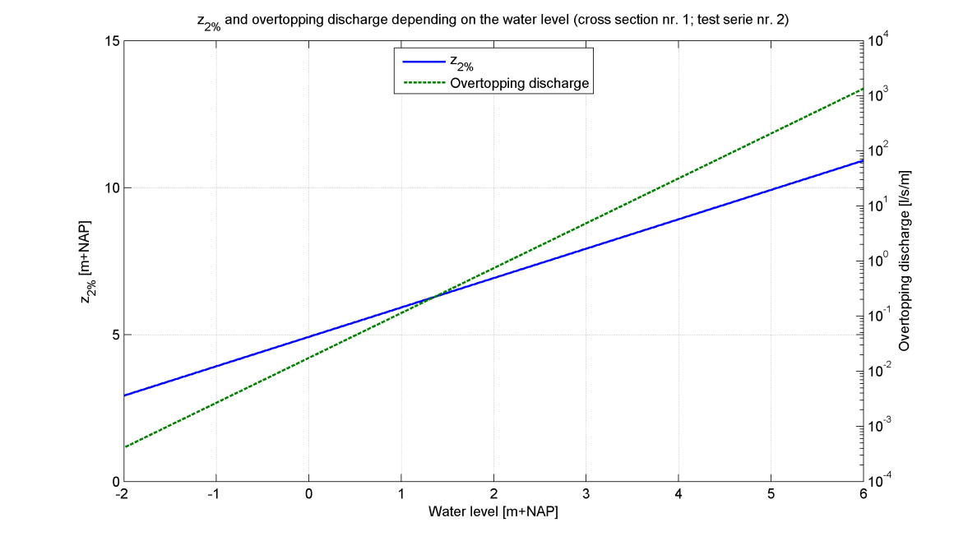

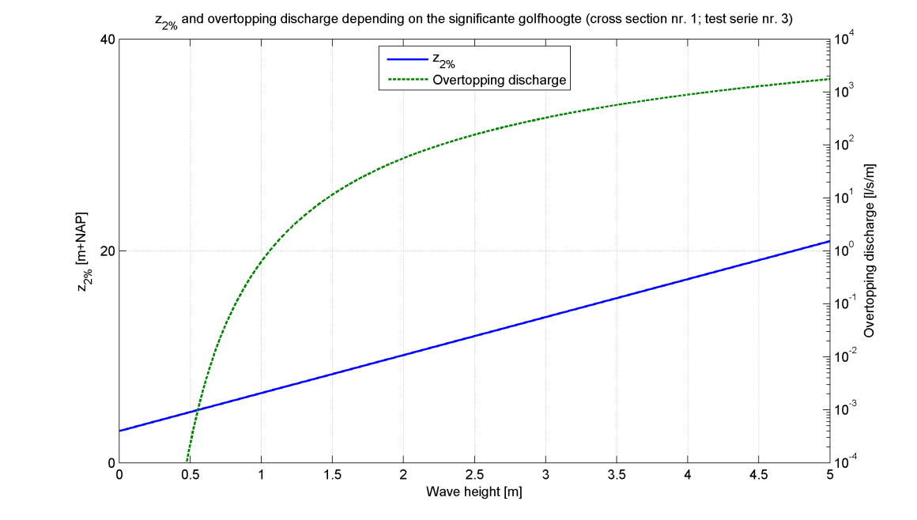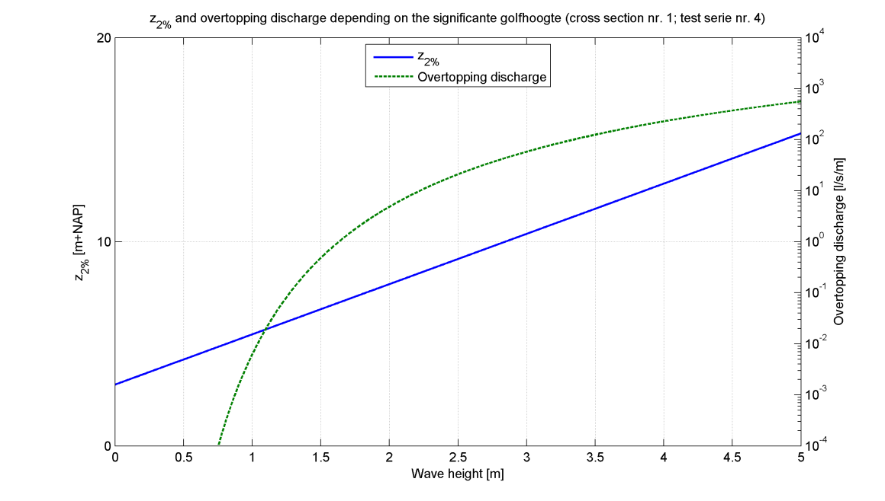

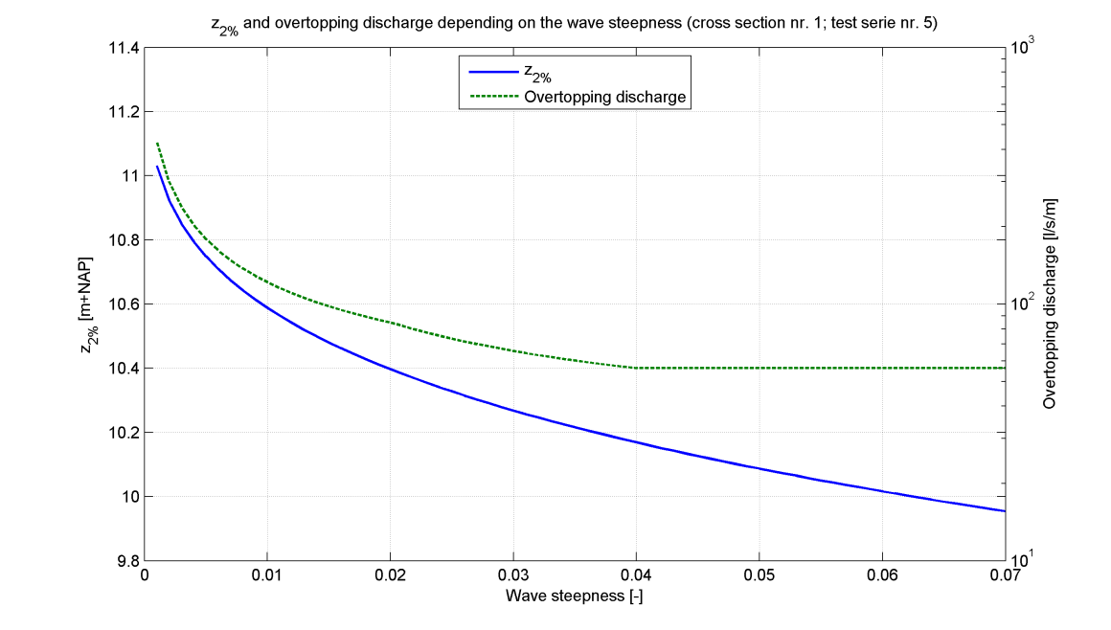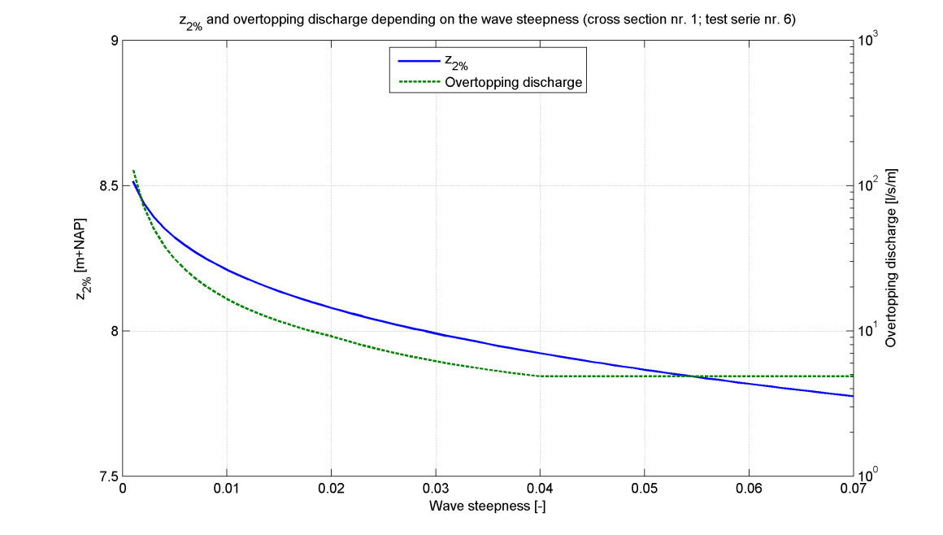

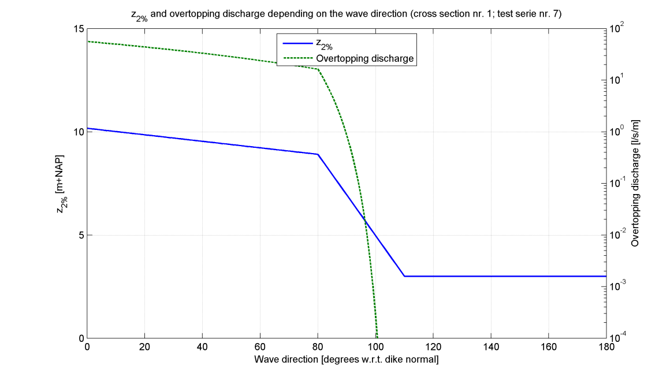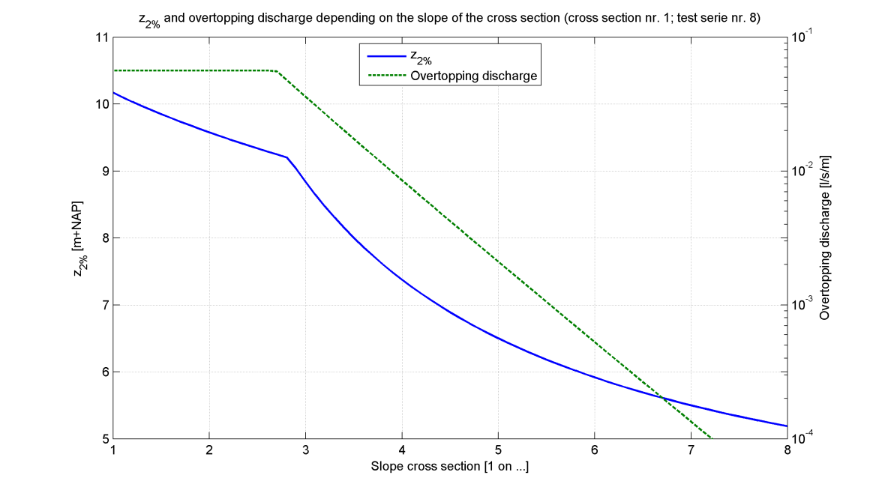

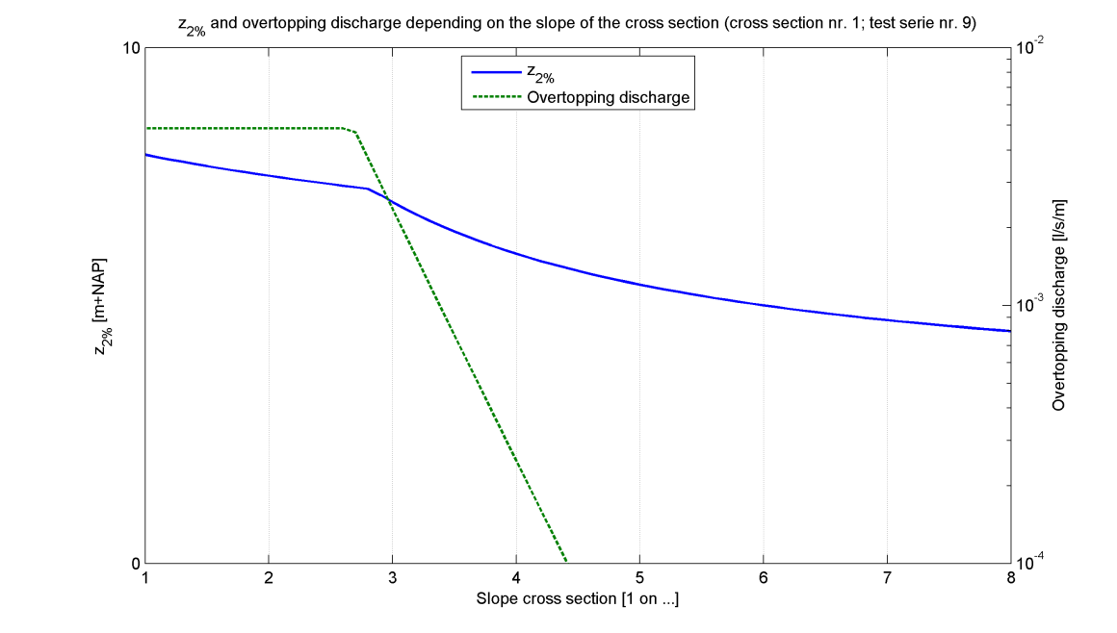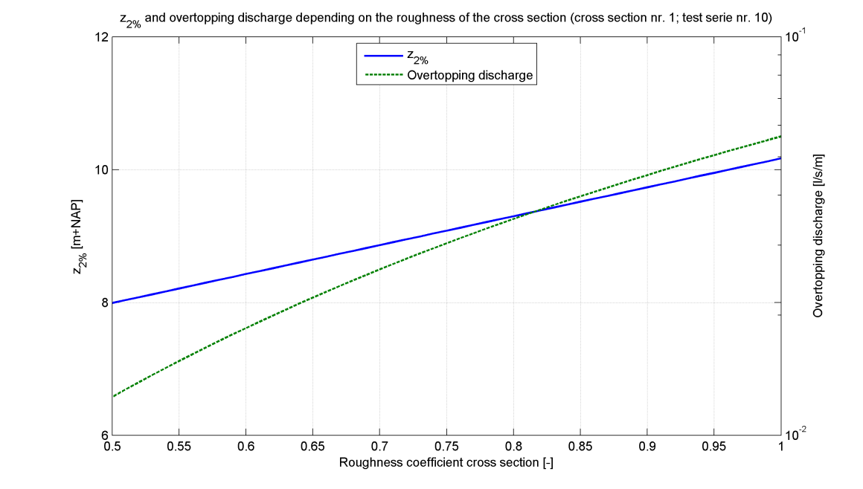

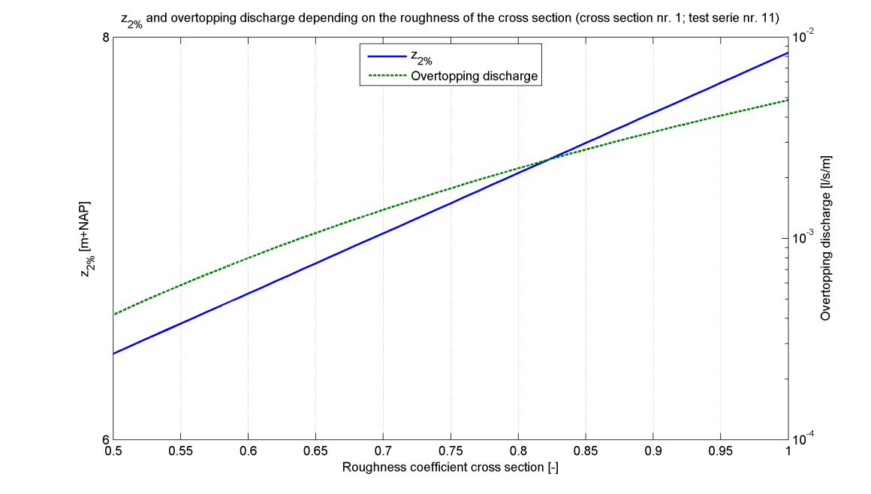

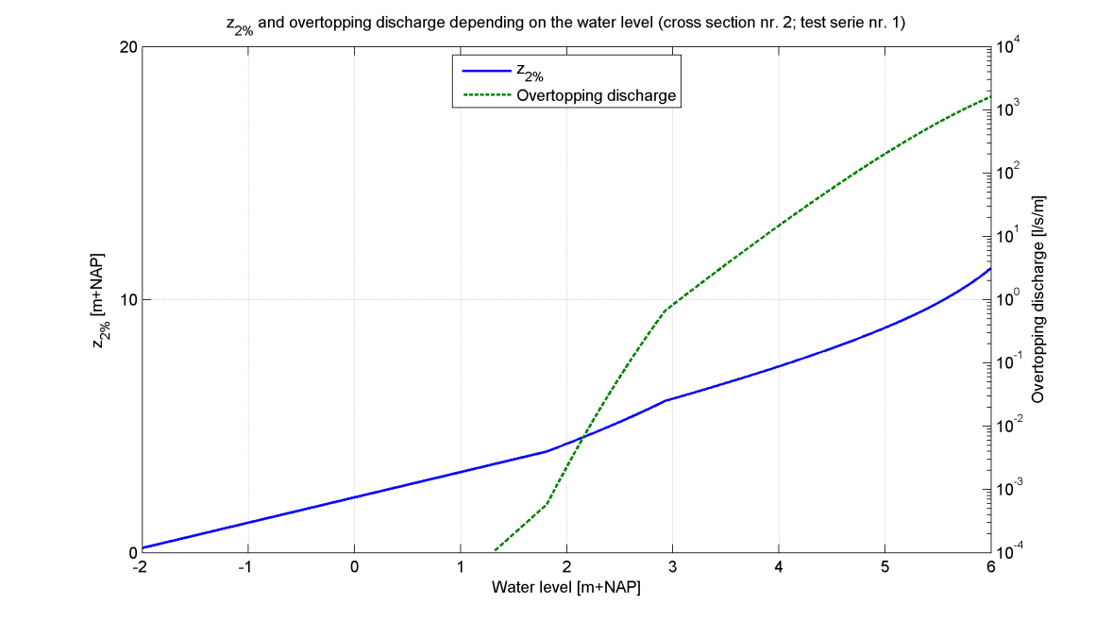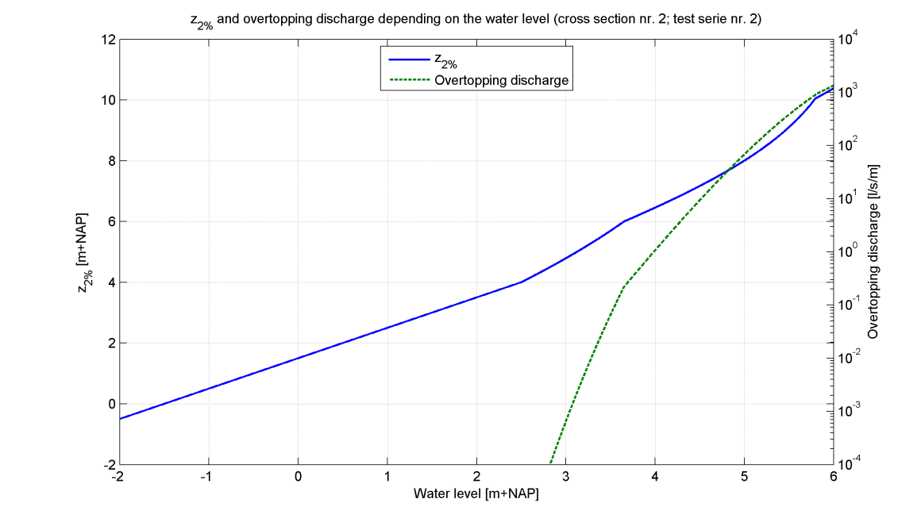

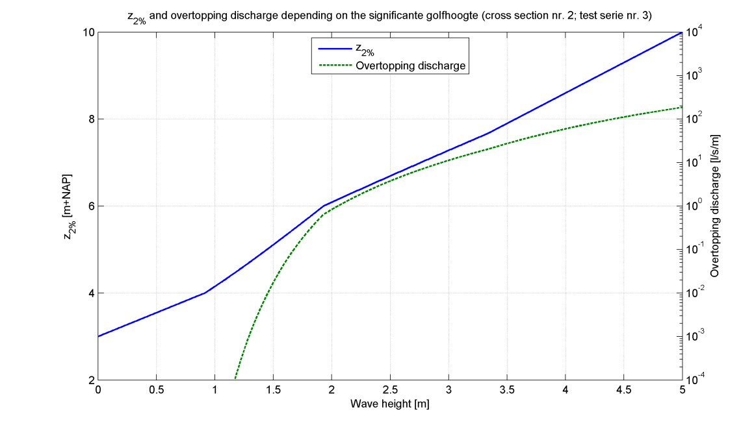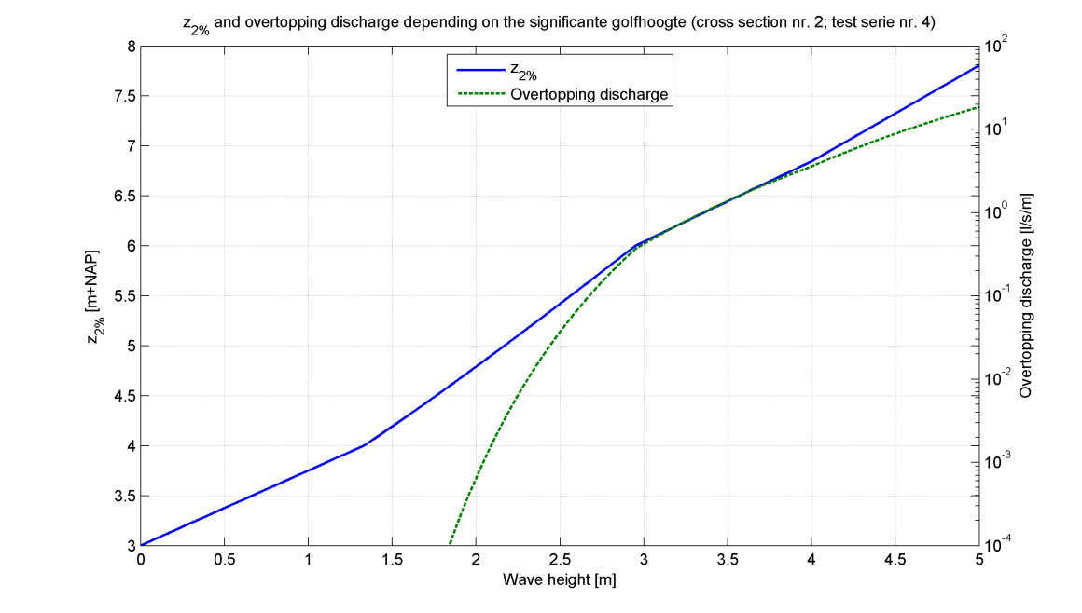

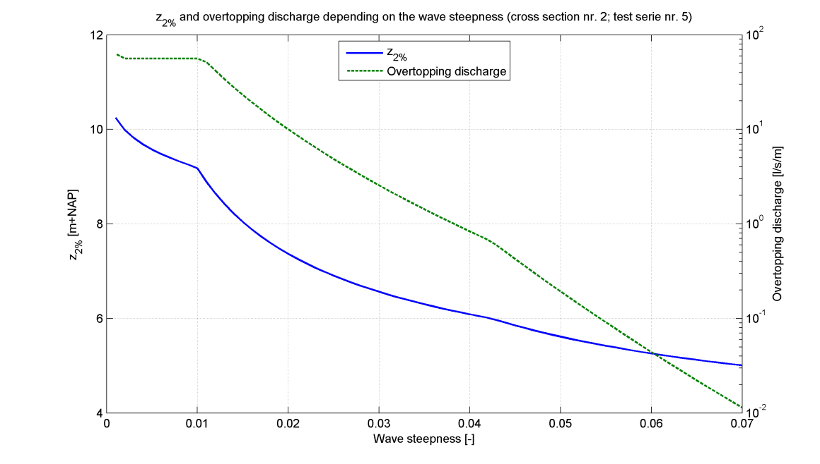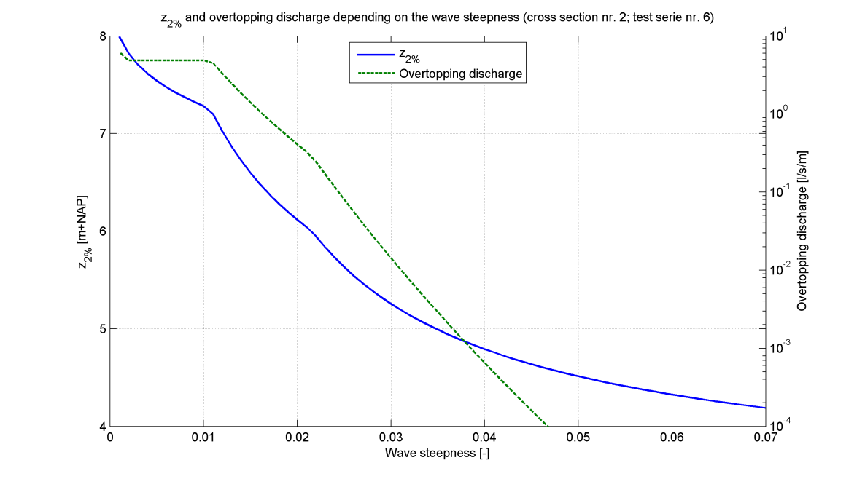

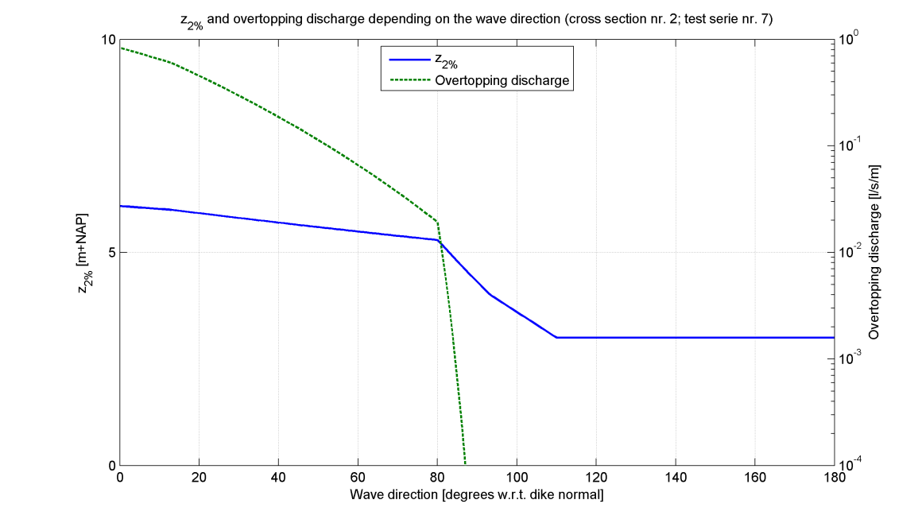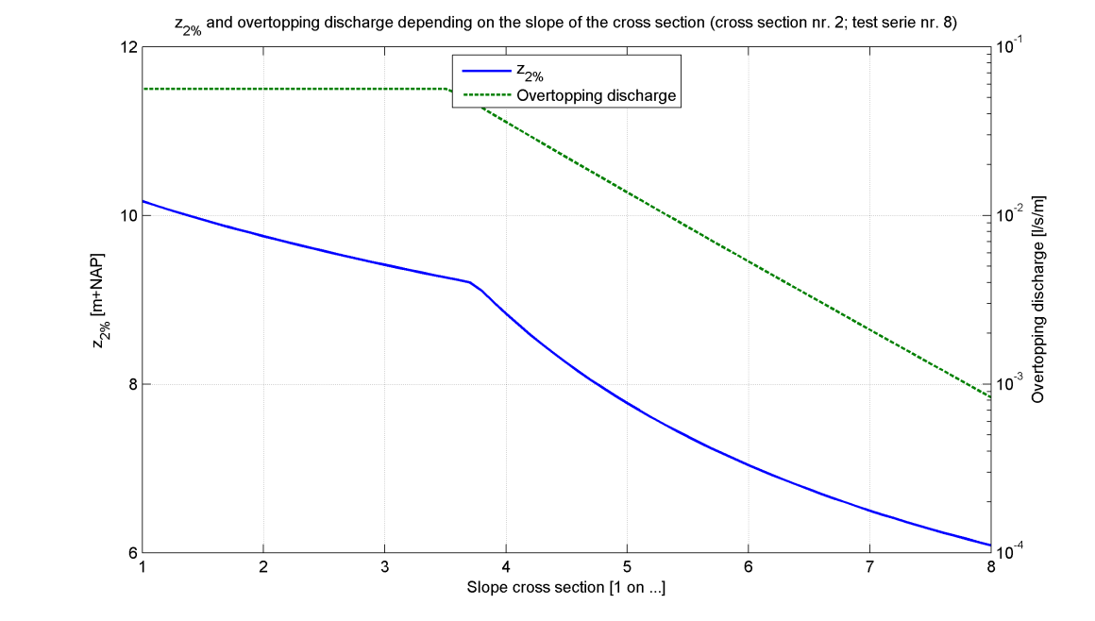

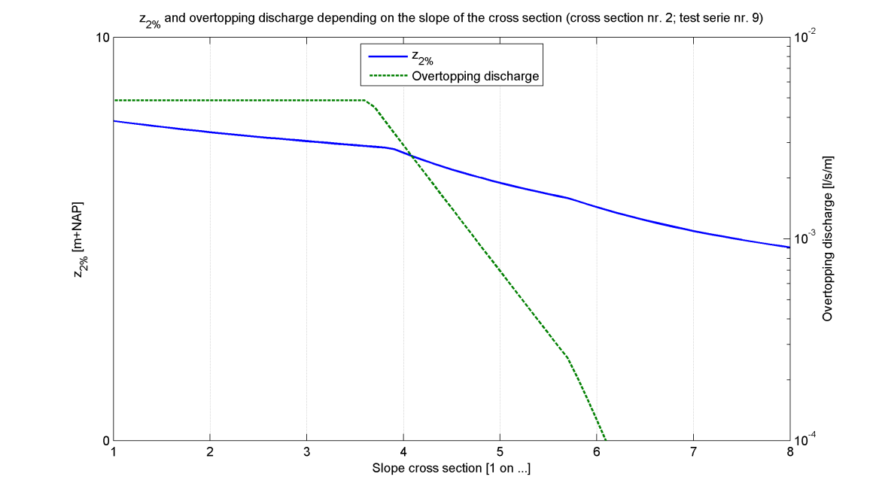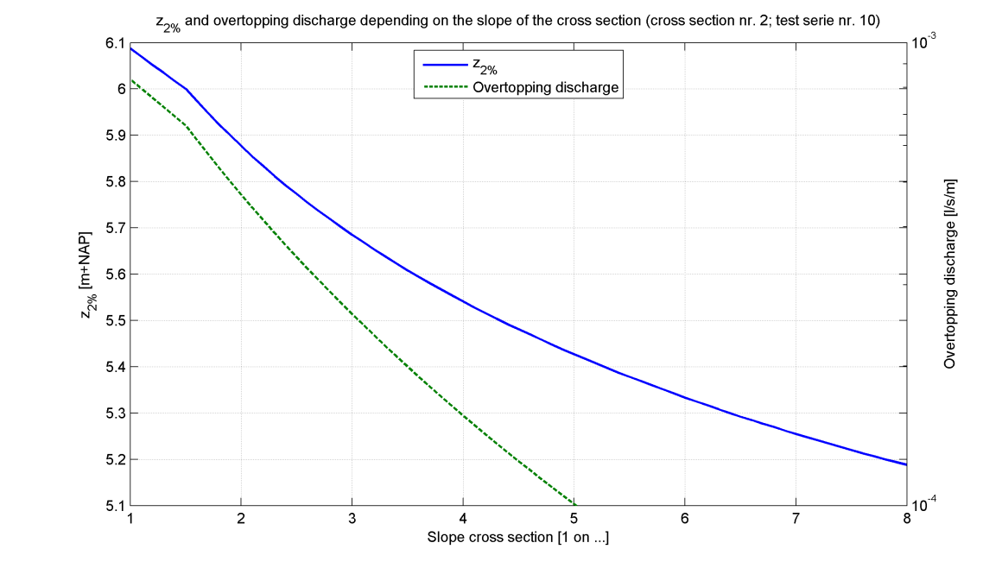

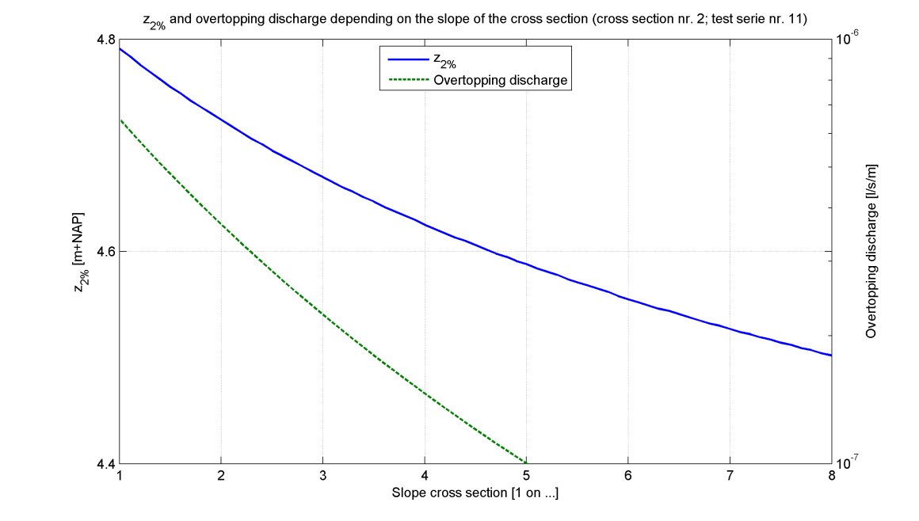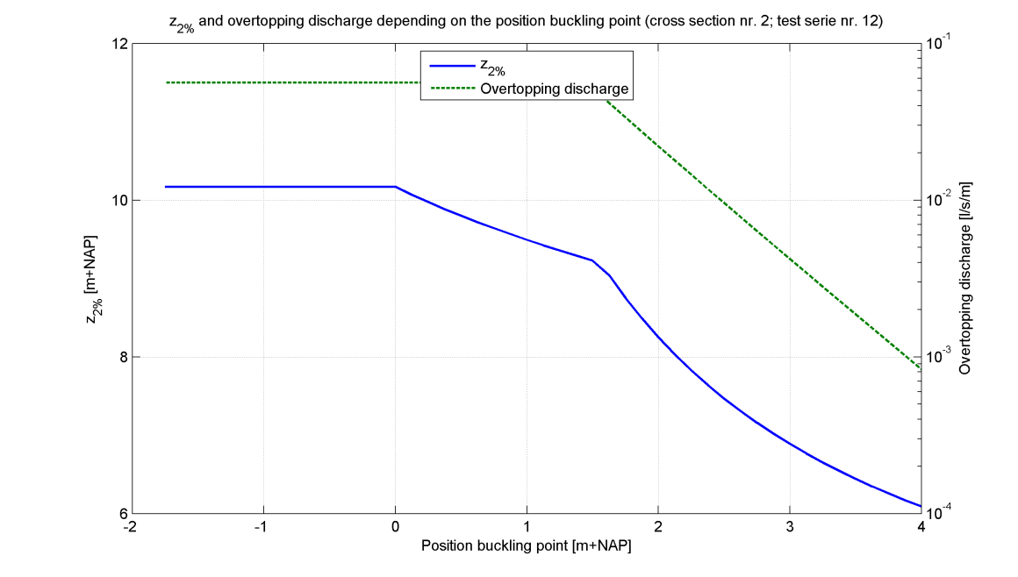

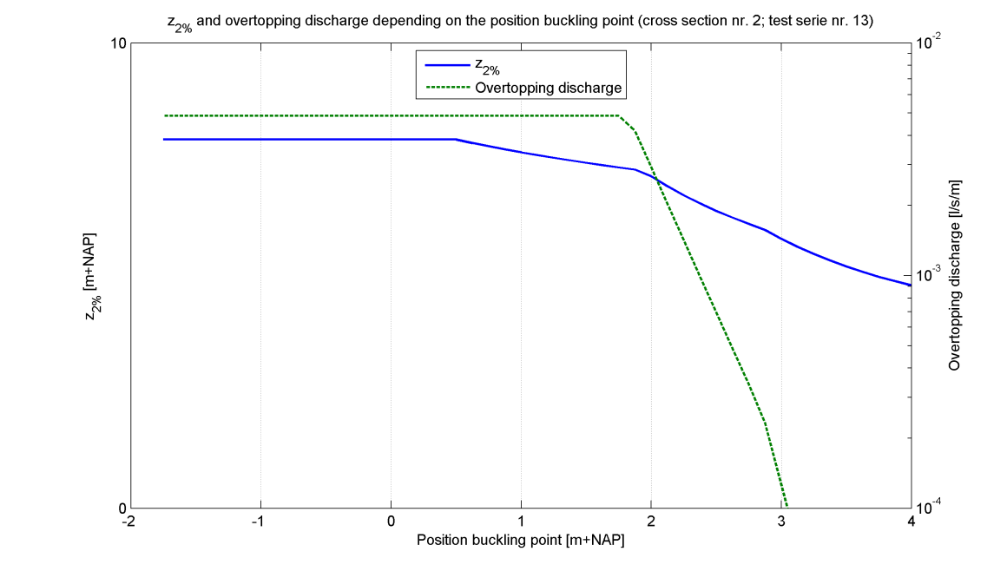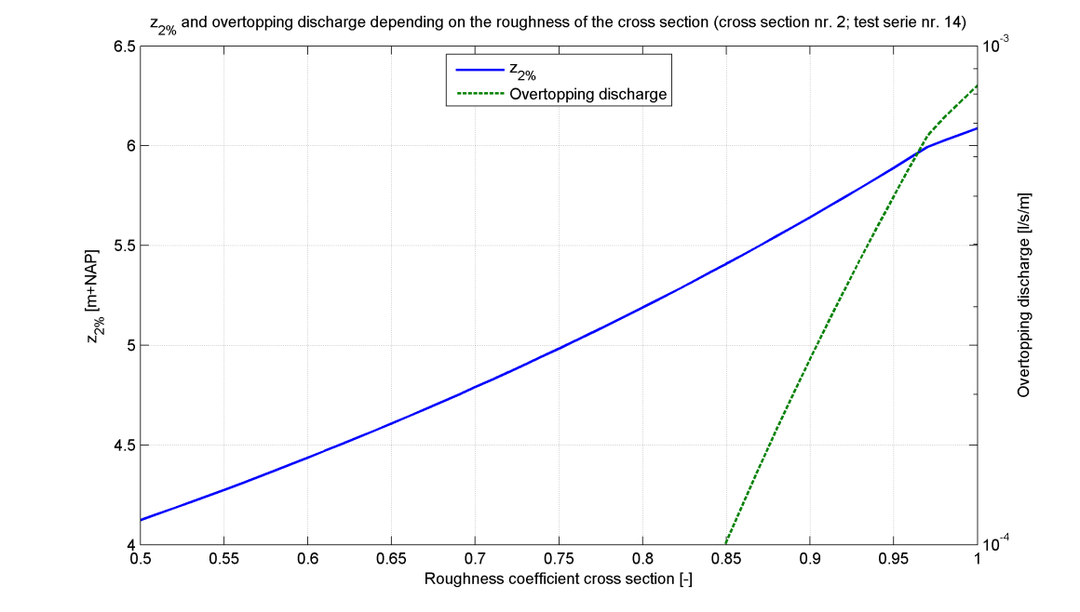

|  |
| --- |
| Cross section 2 |

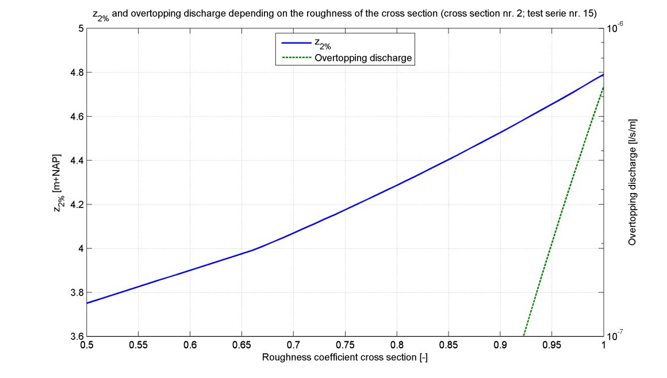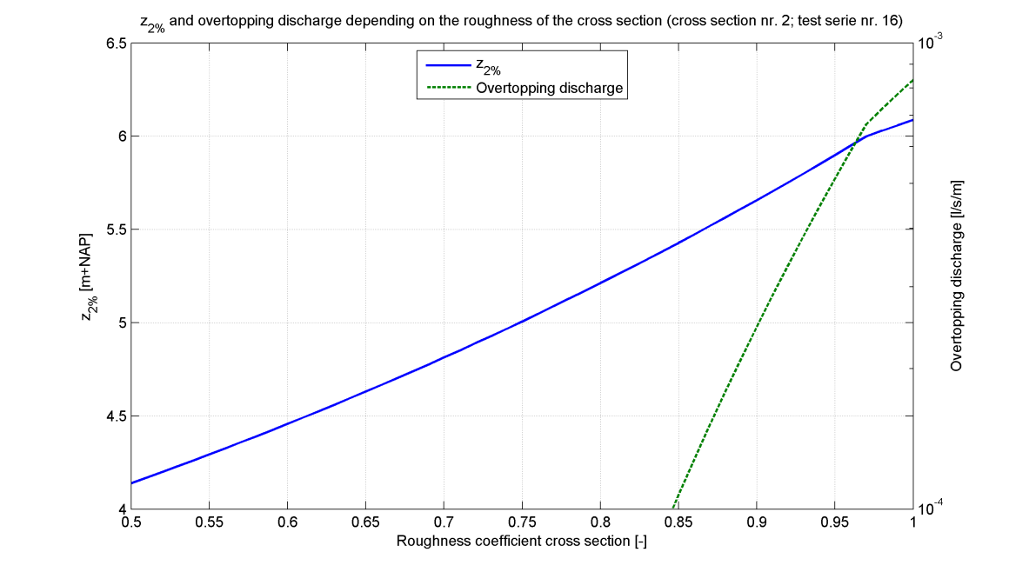

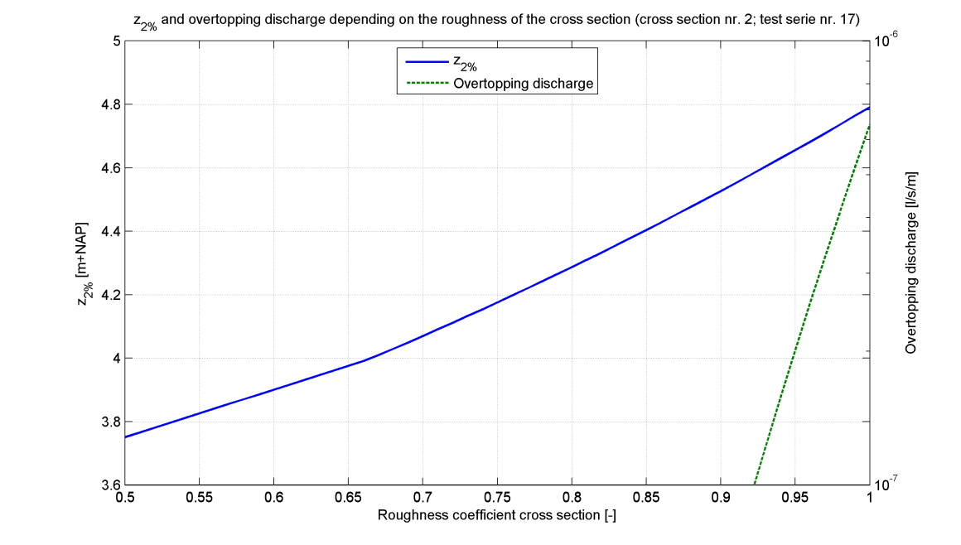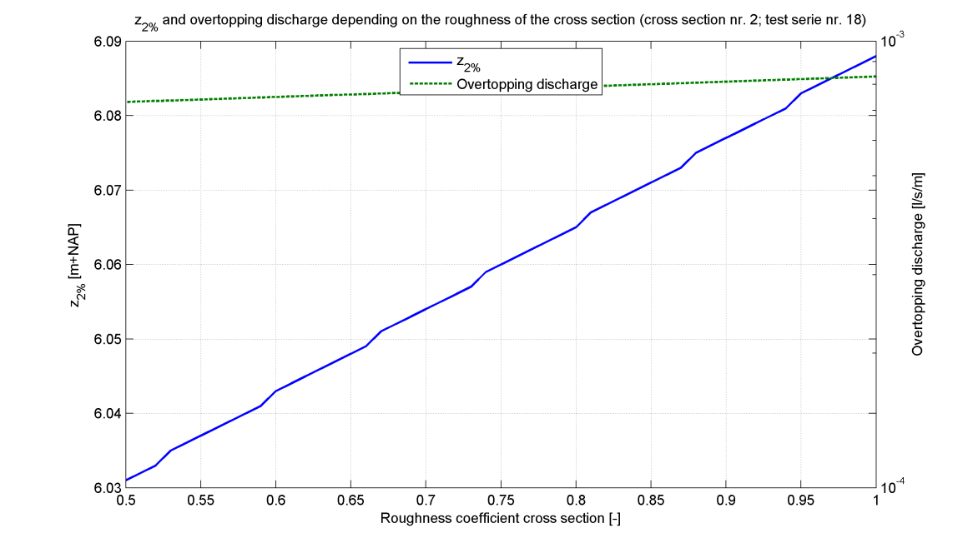

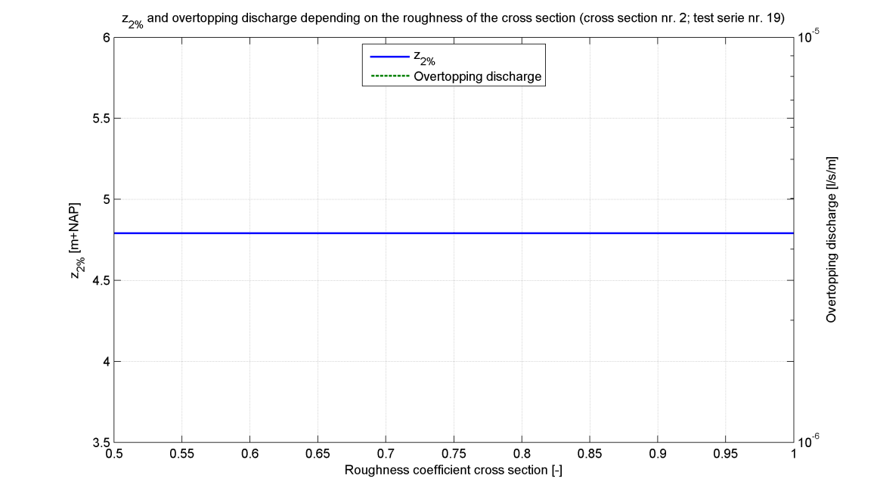

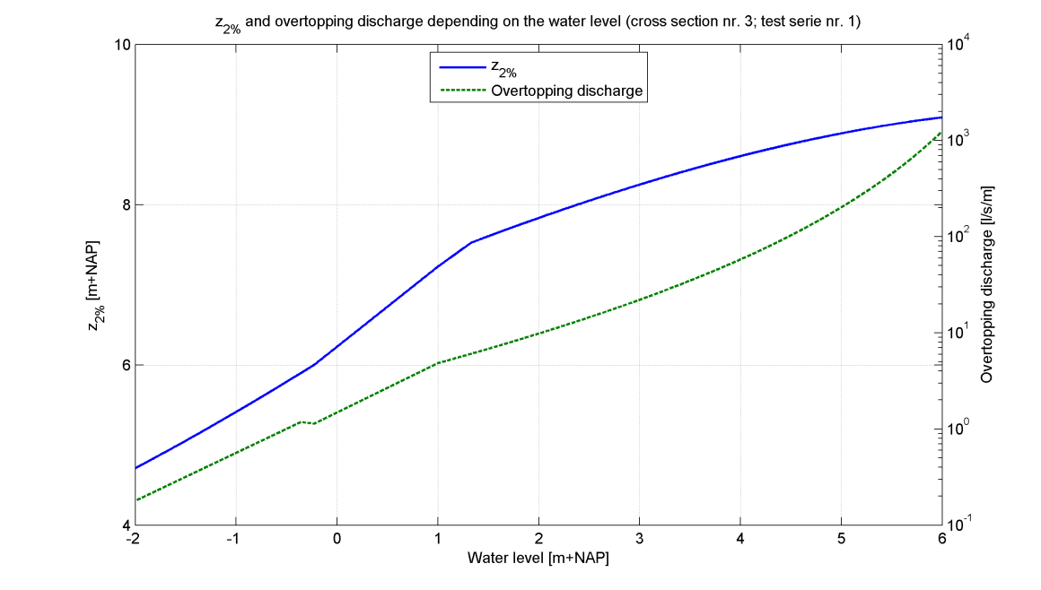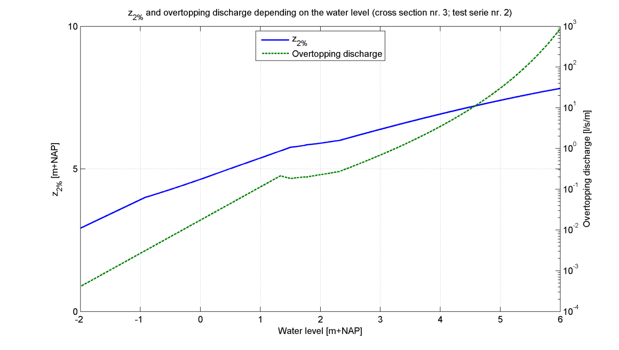

|  |
| --- |
| Cross section 3 |

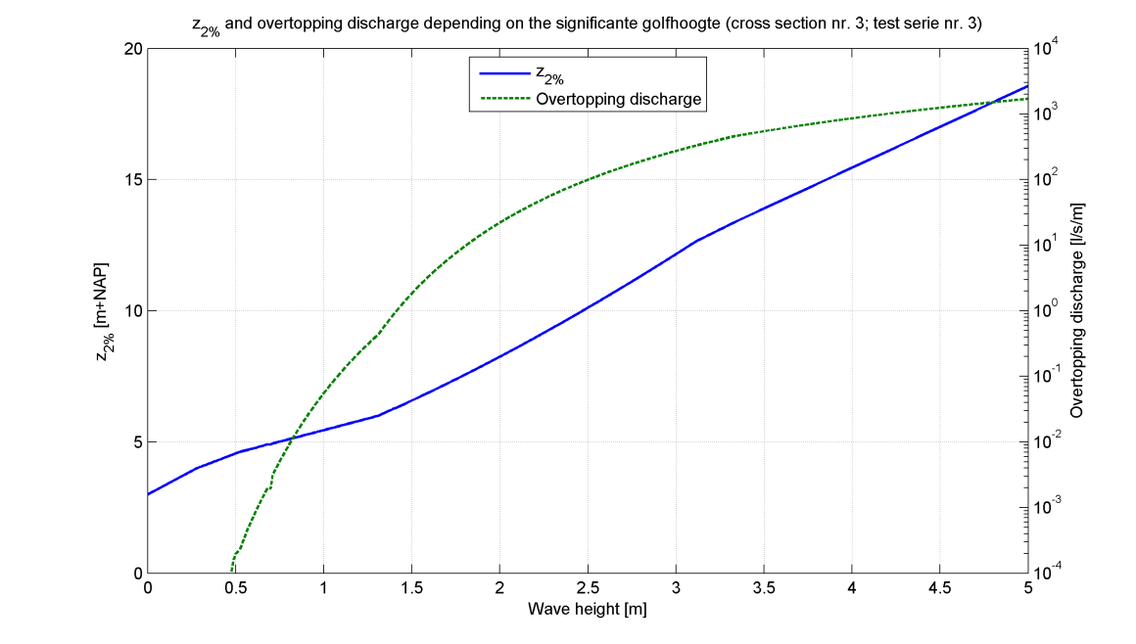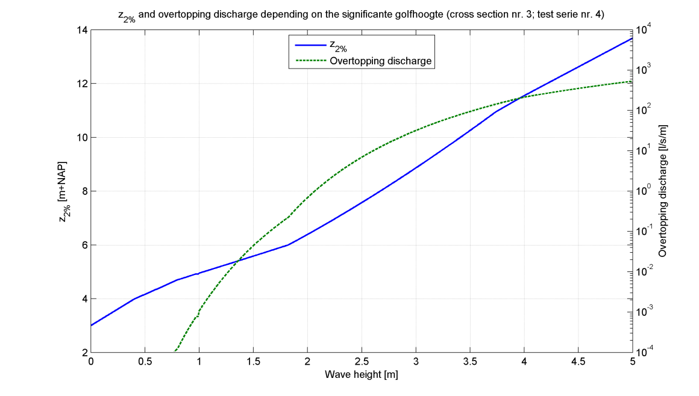

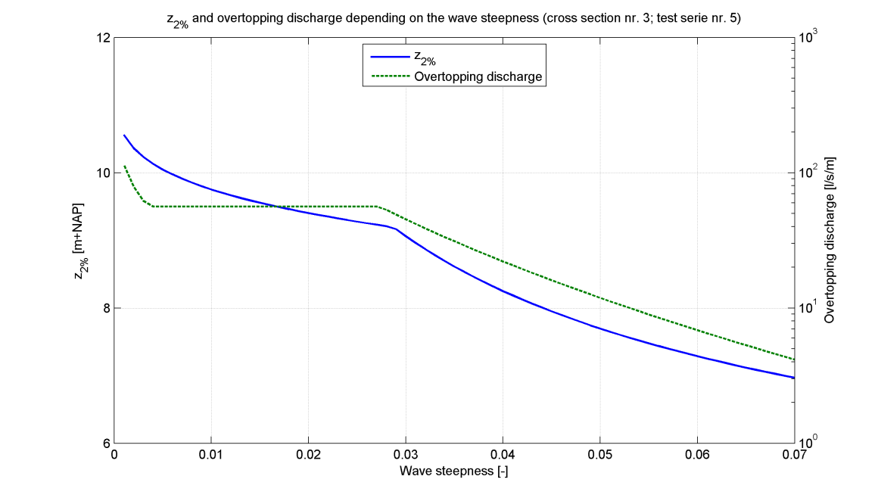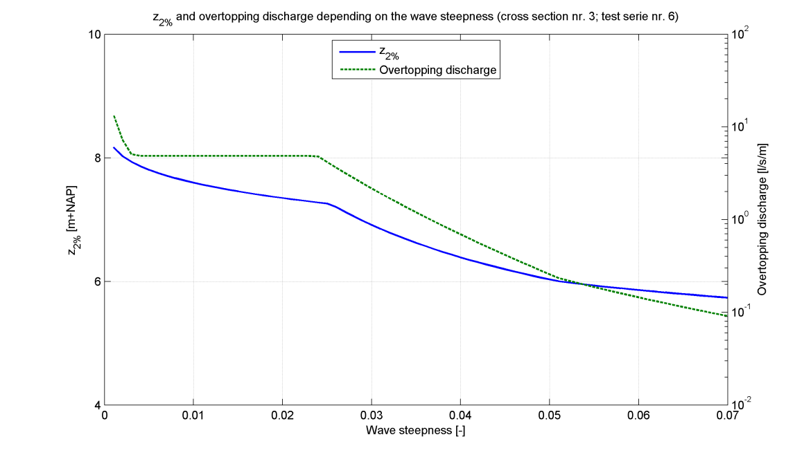

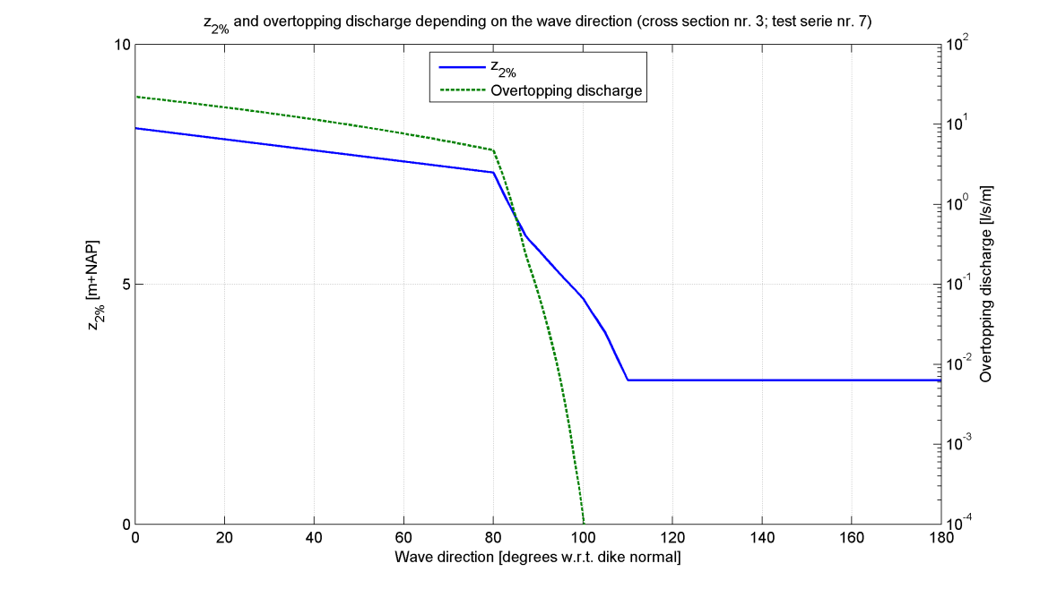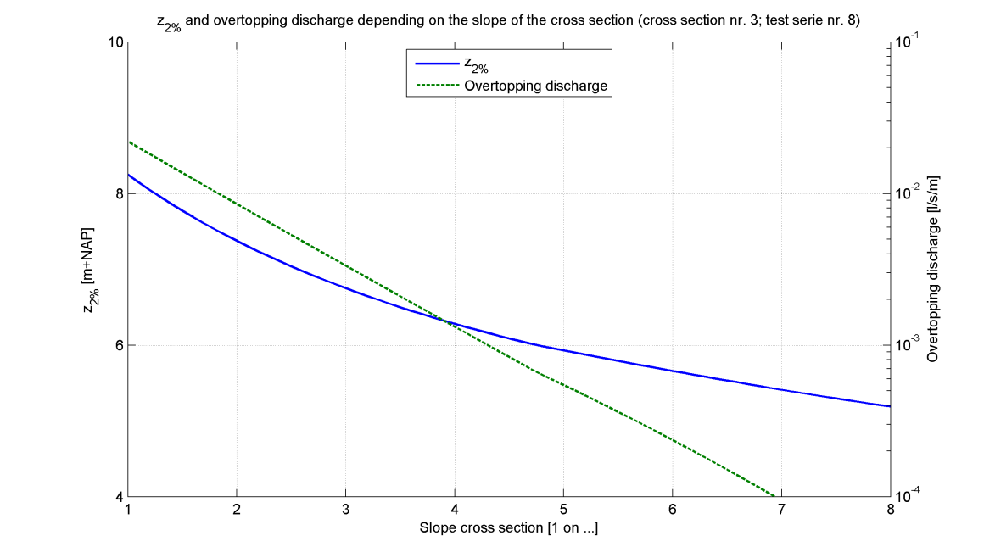

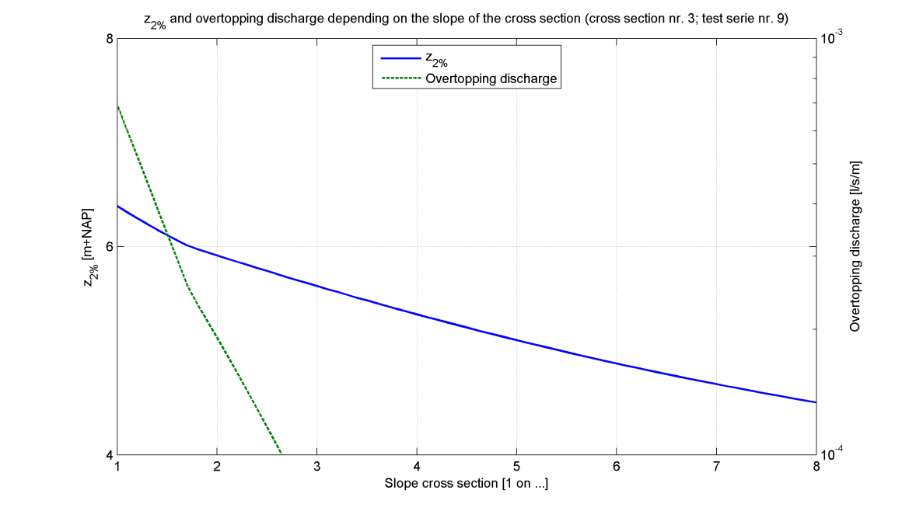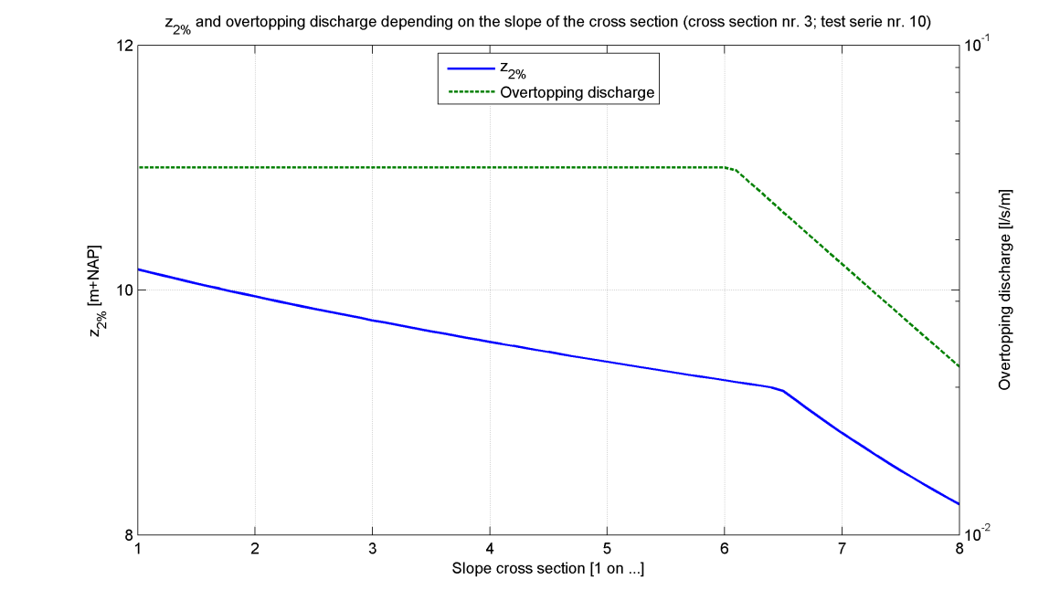

|  |
| --- |
| Cross section 3 |

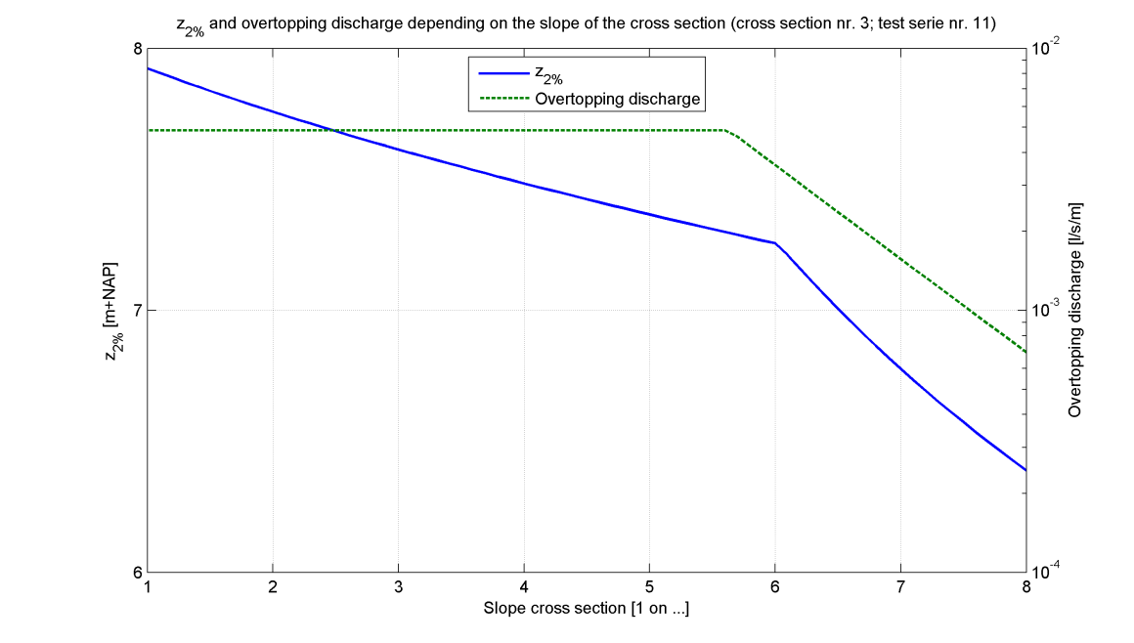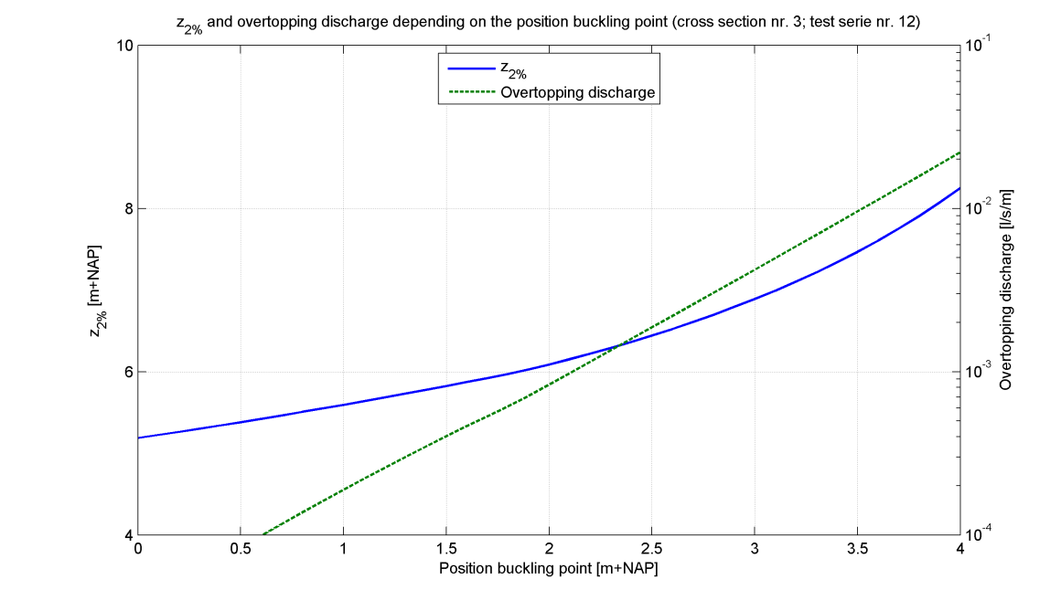

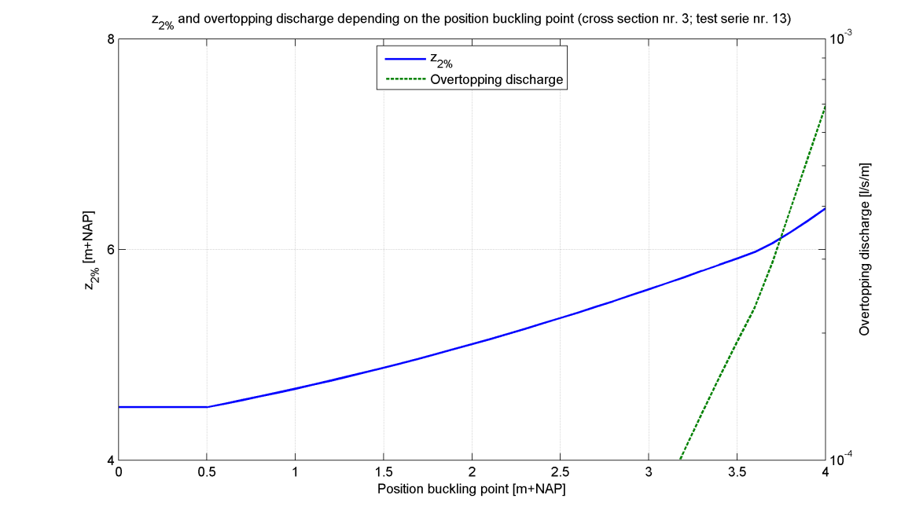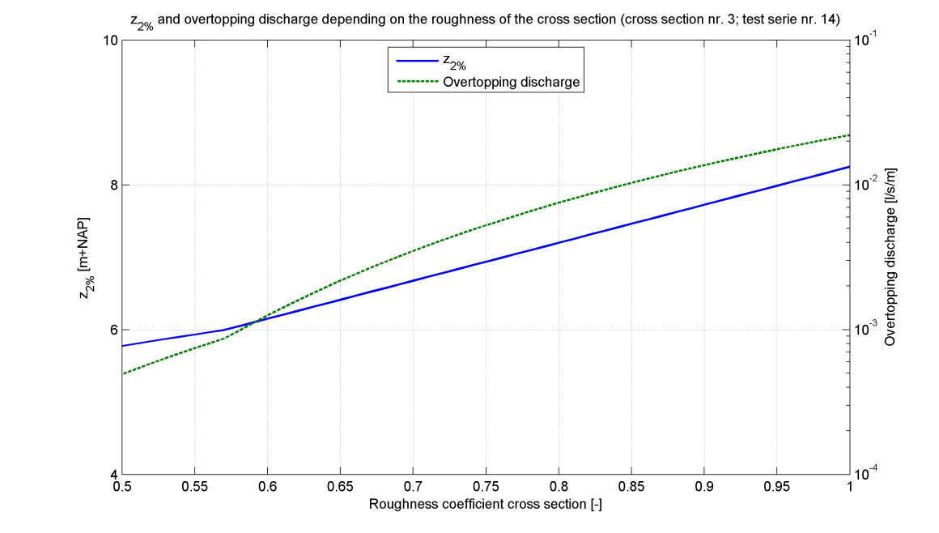

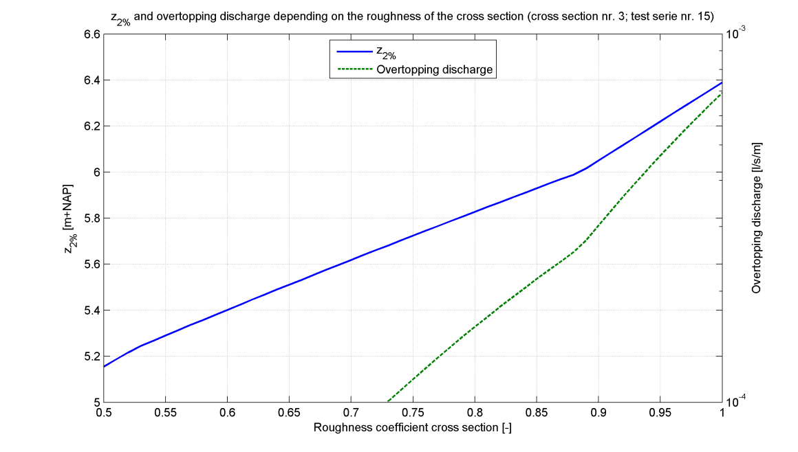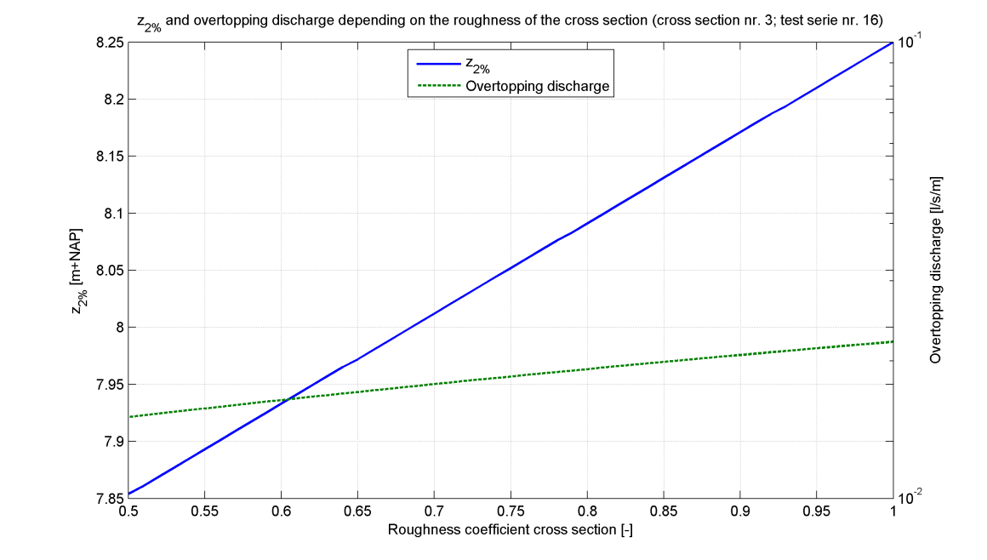

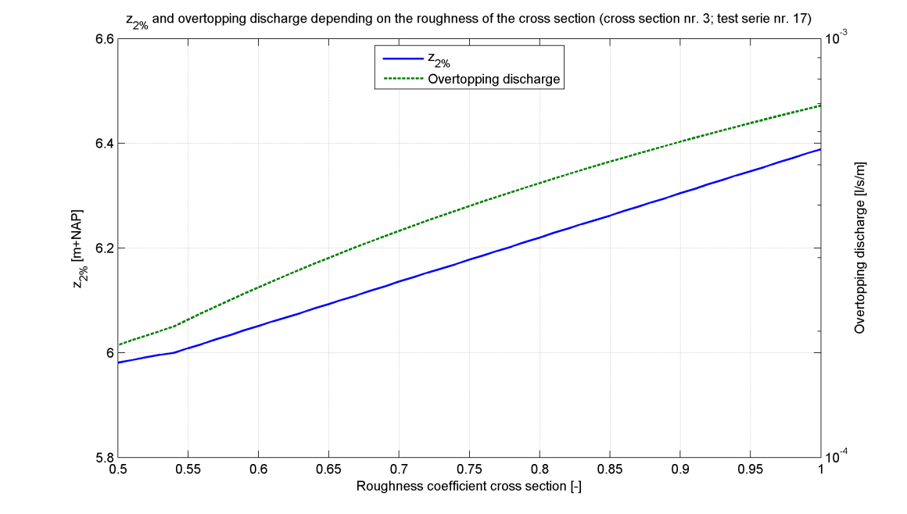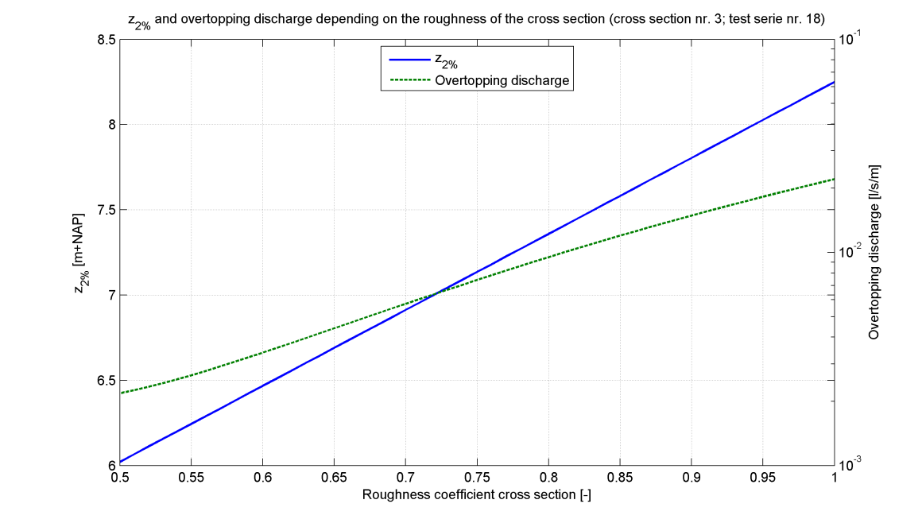

|  |
| --- |
| Cross section 3 |

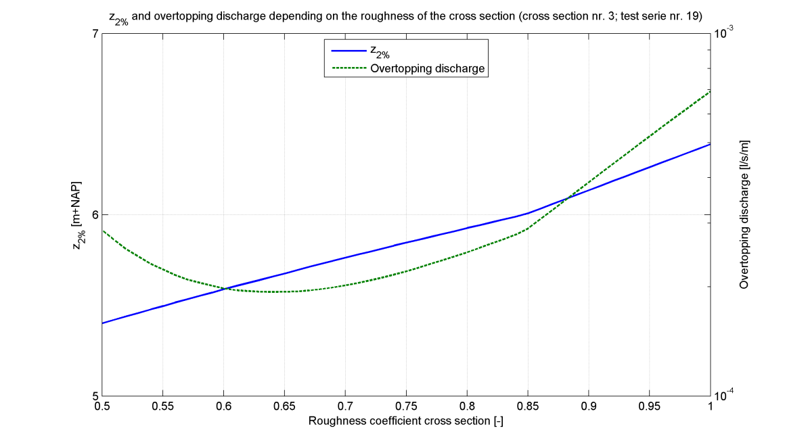

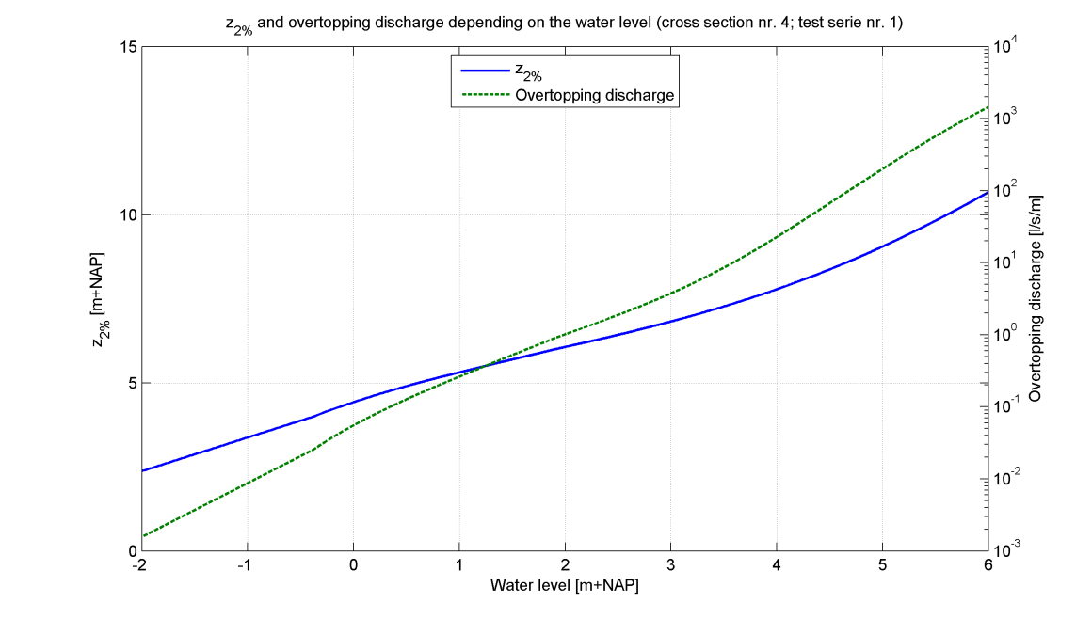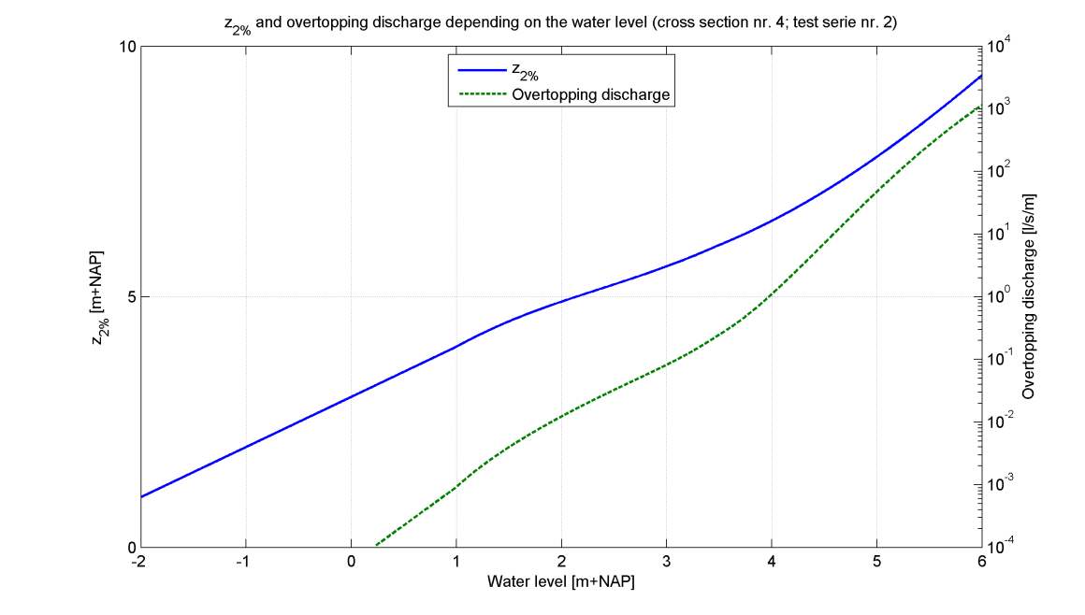

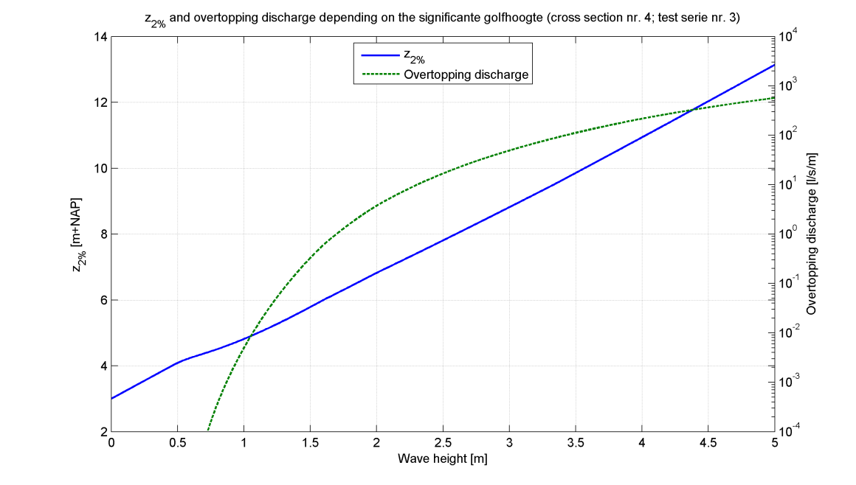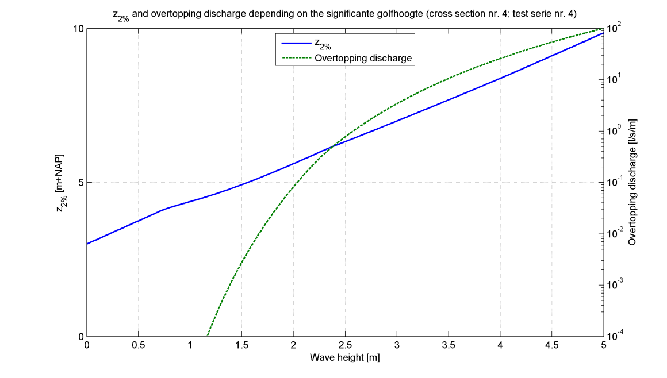

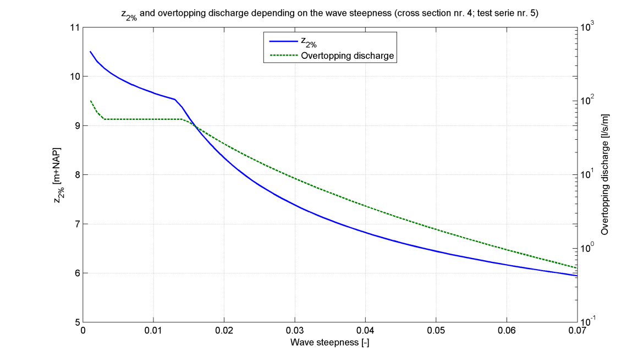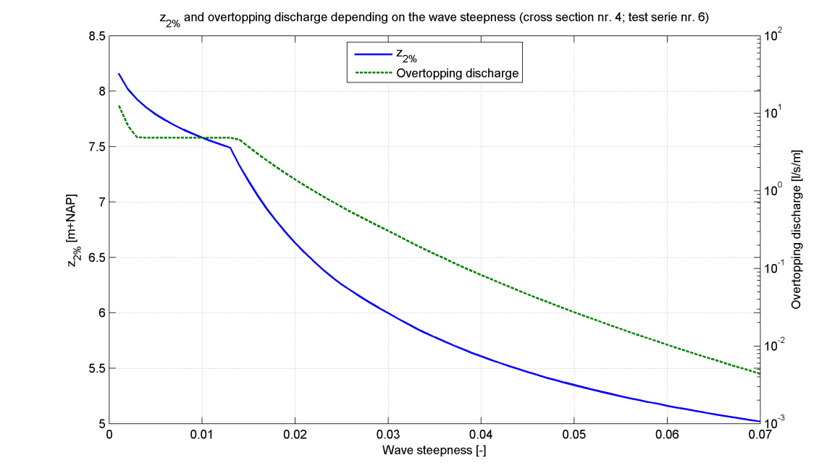

|  |
| --- |
| Cross section 4 |

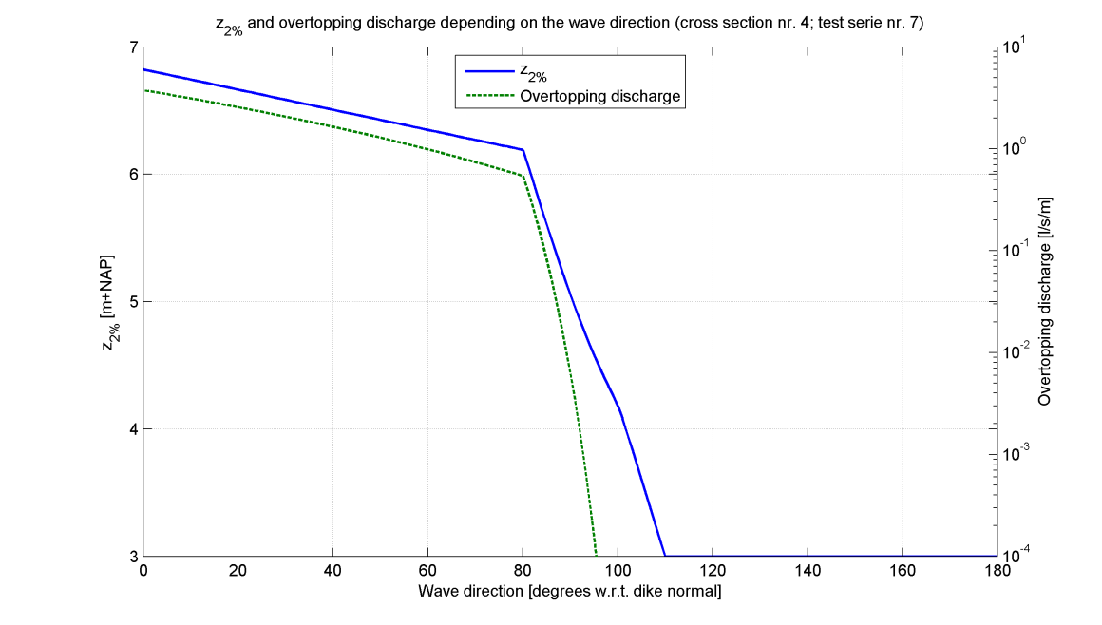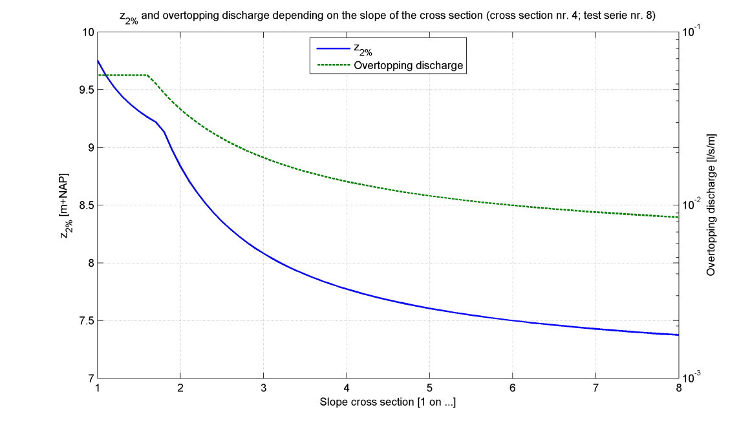

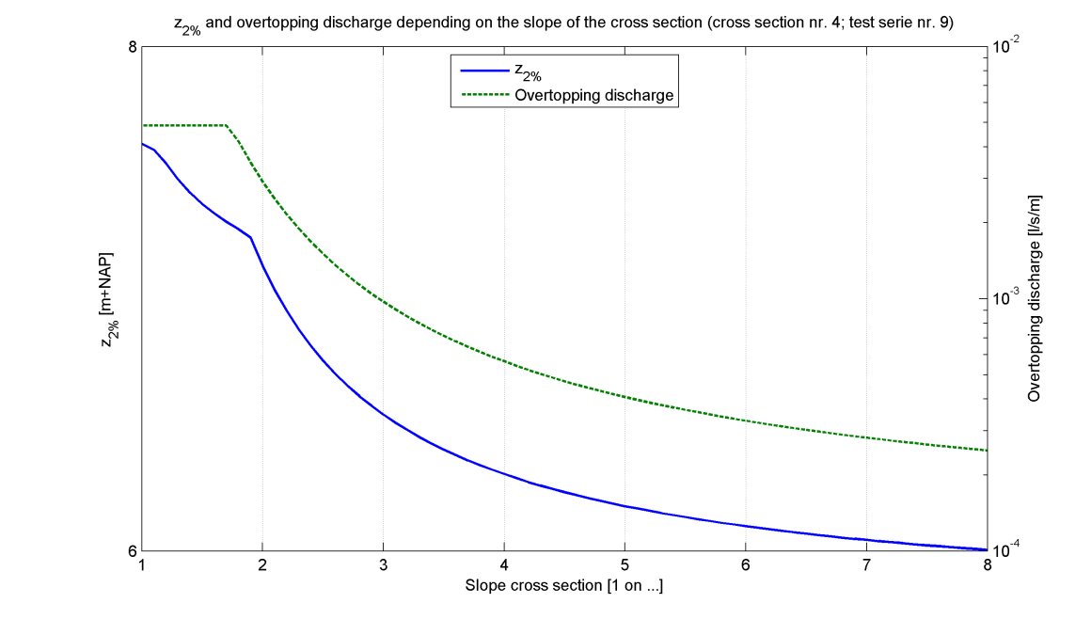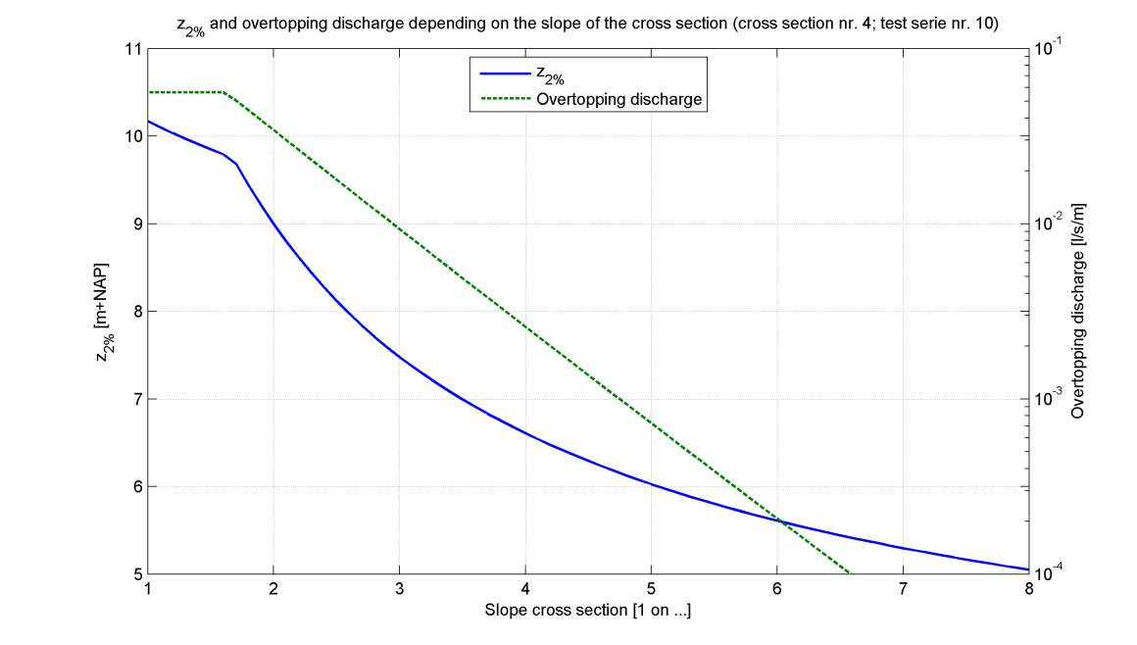

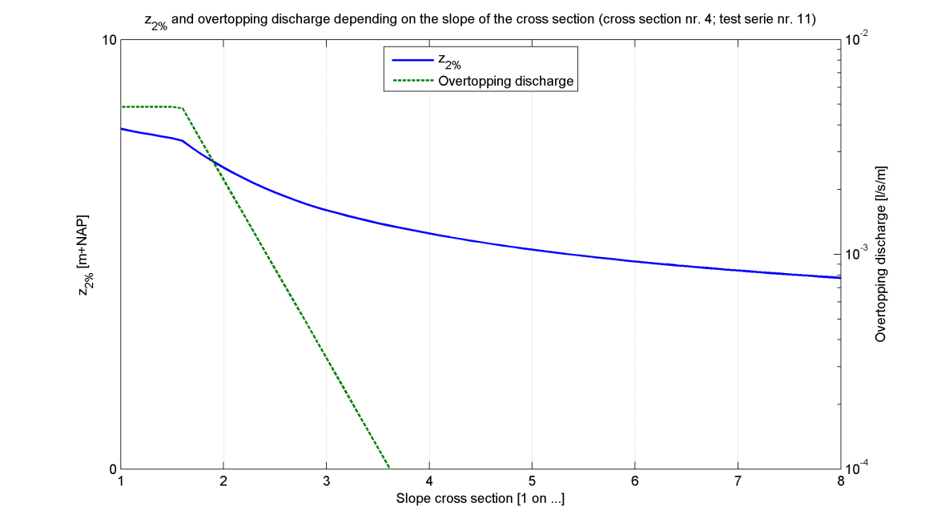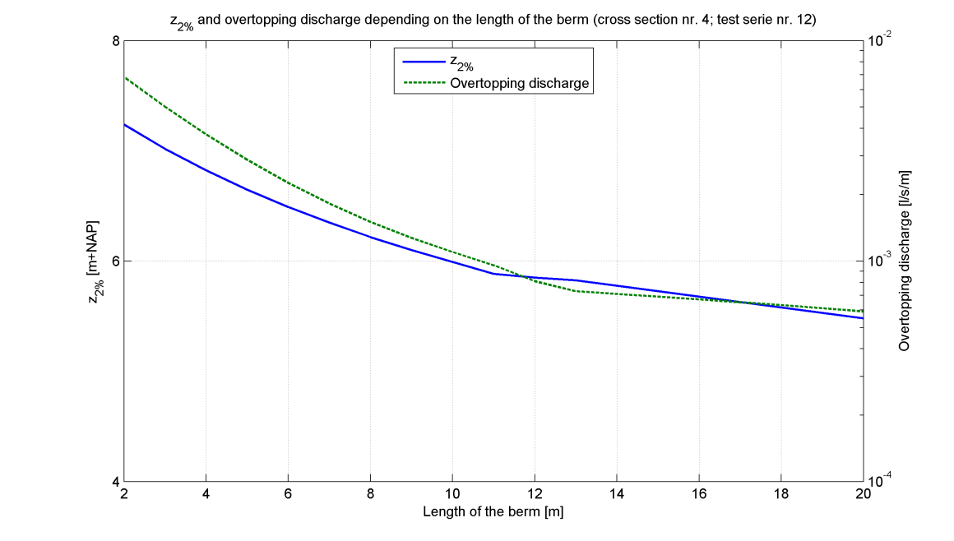

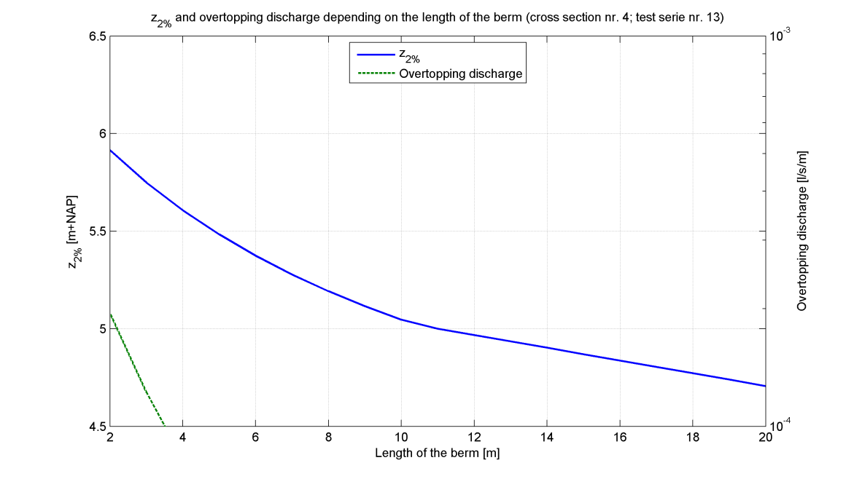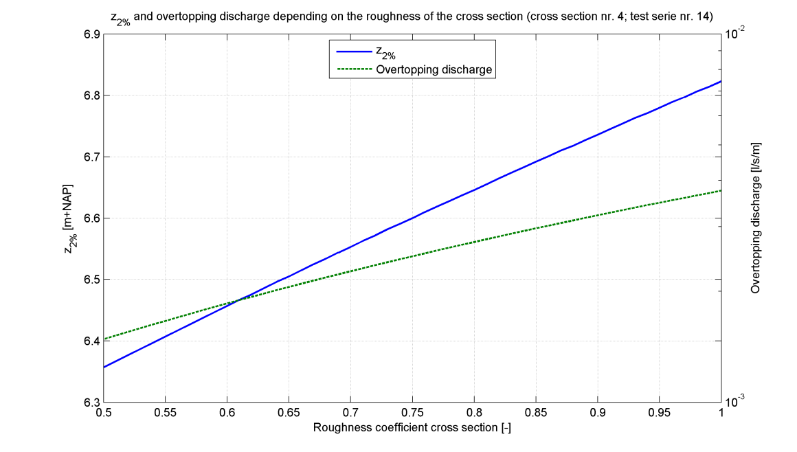

|  |
| --- |
| Cross section 4 |

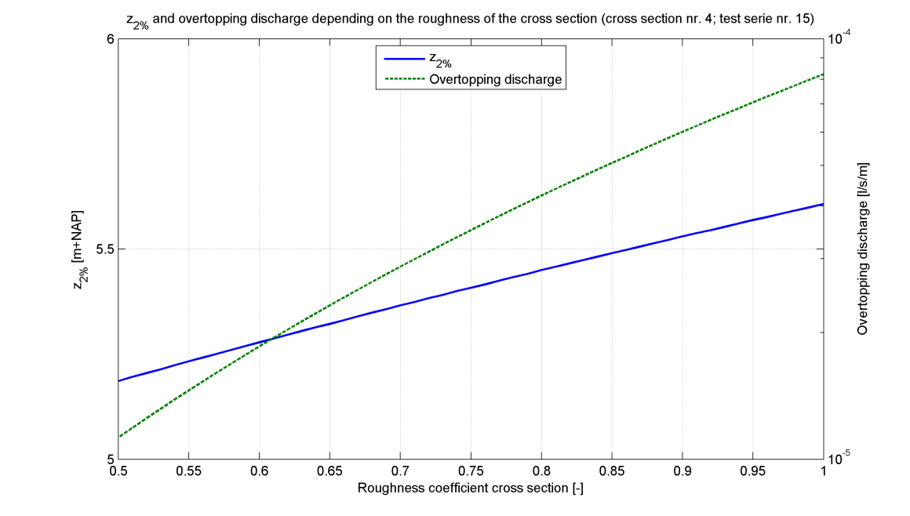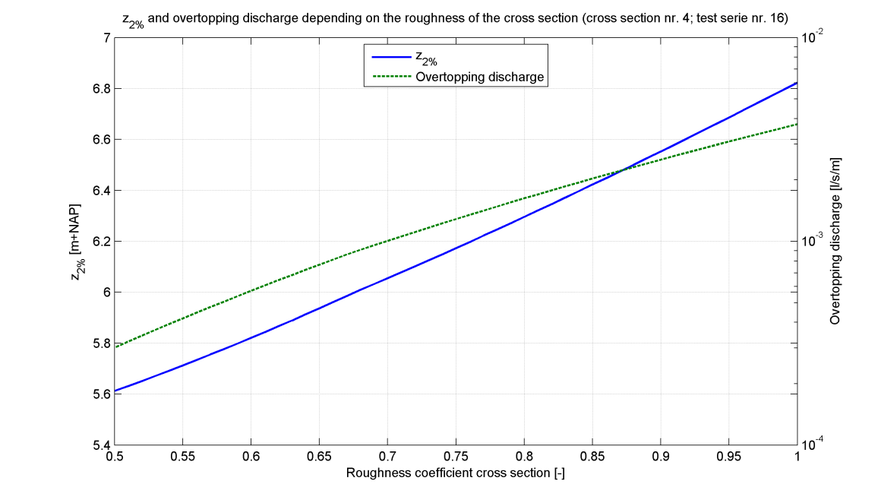

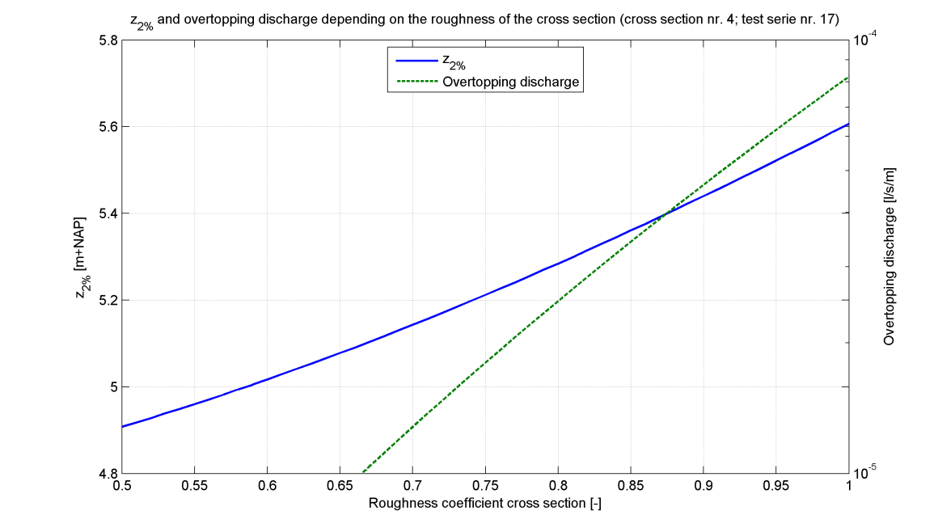

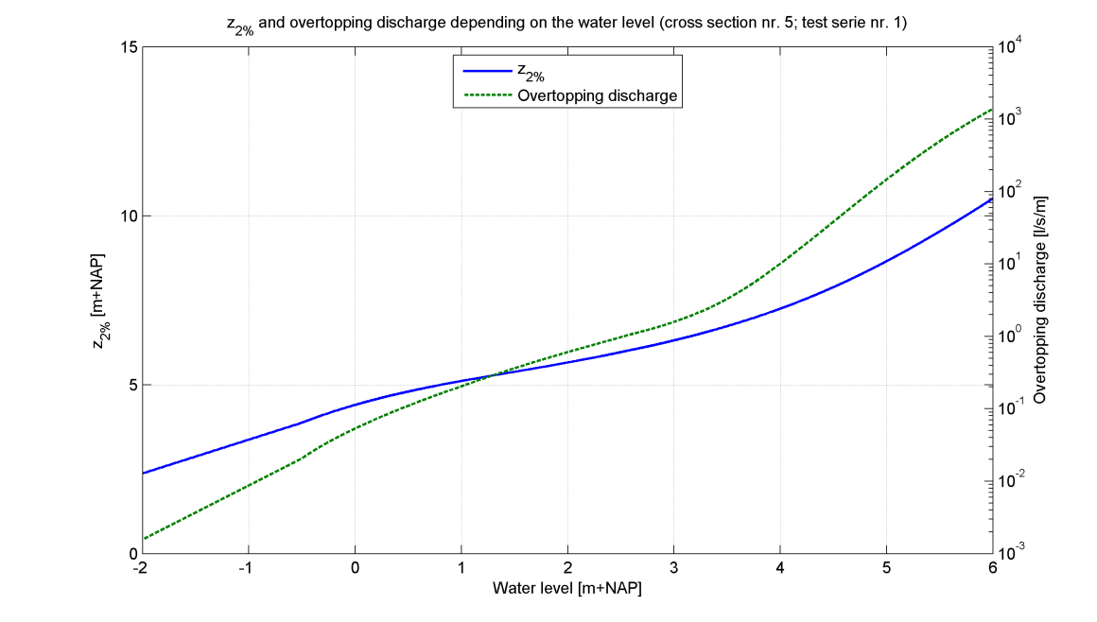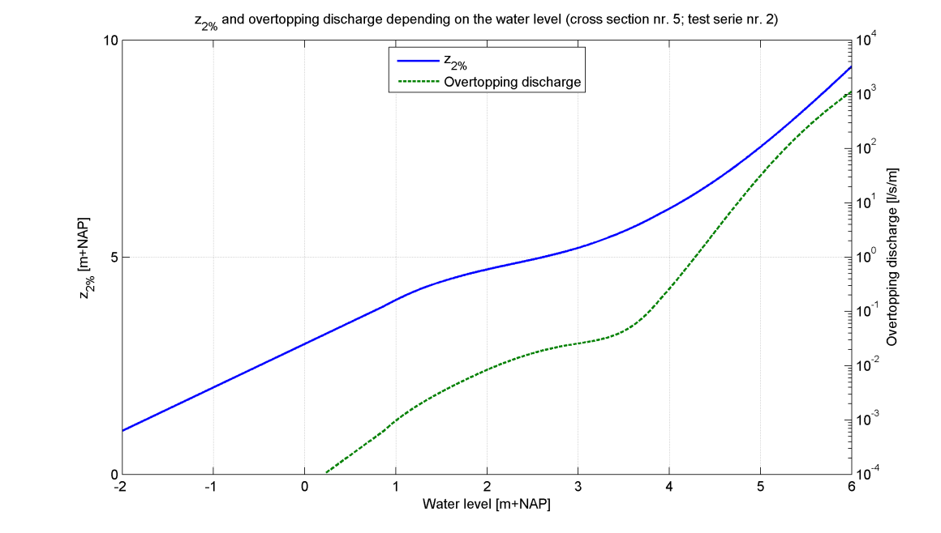

|  |
| --- |
| Cross section 5 |

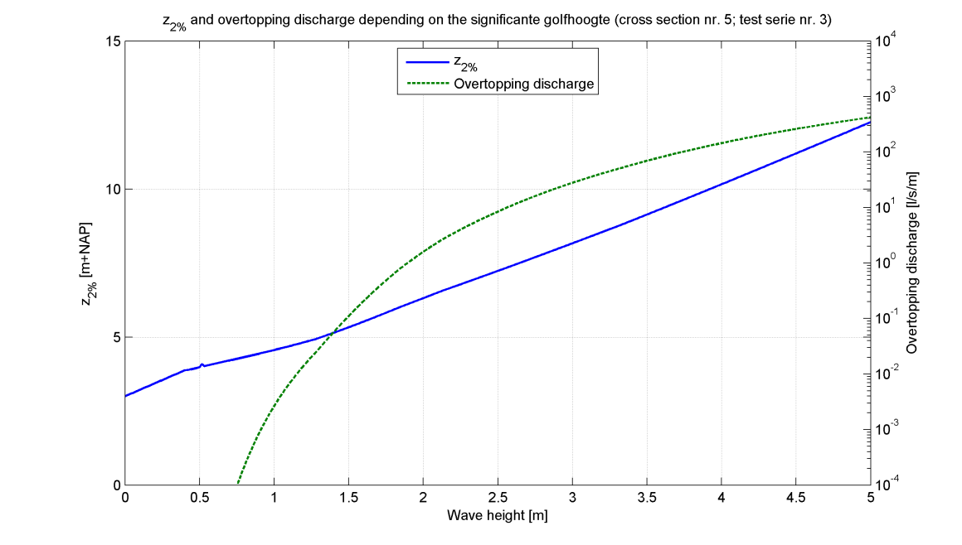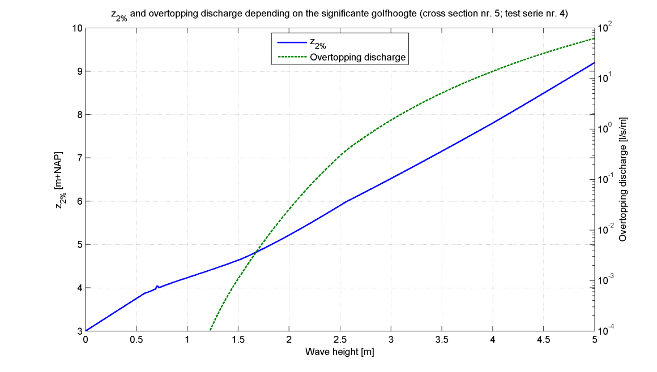

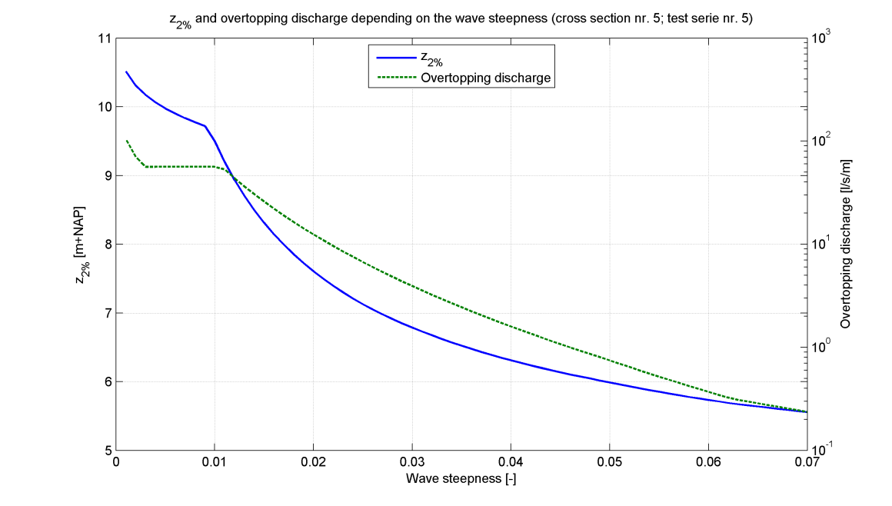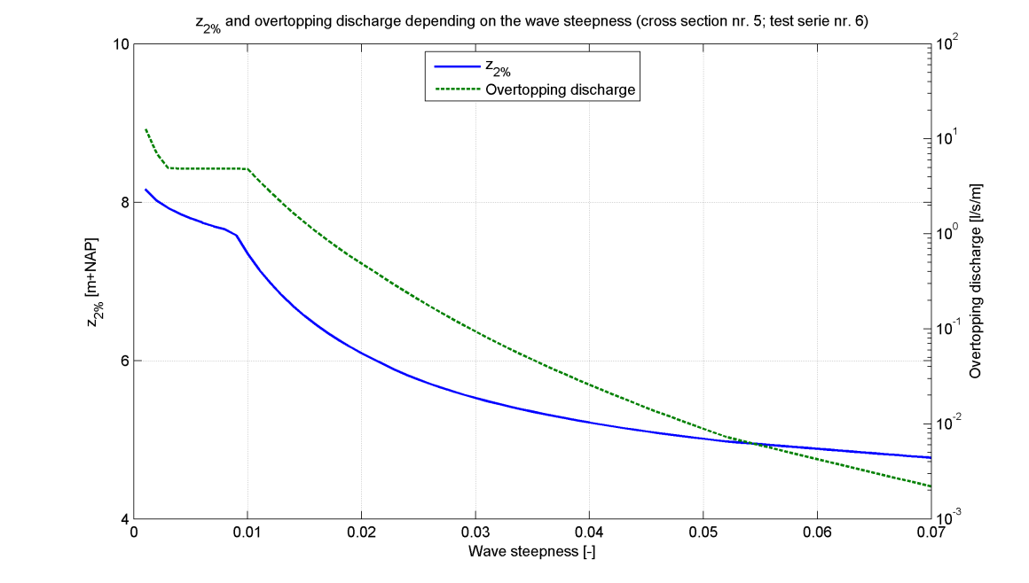

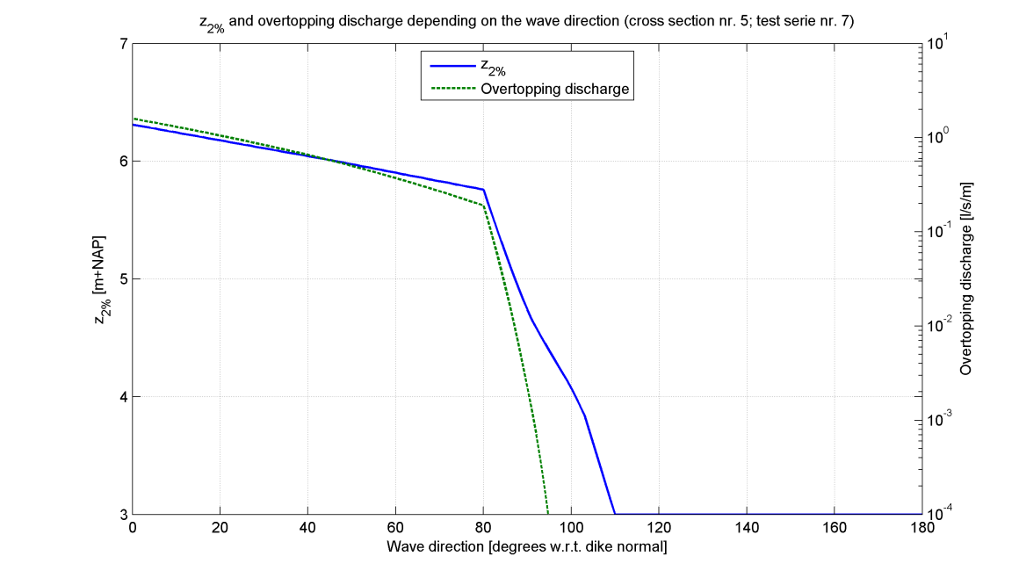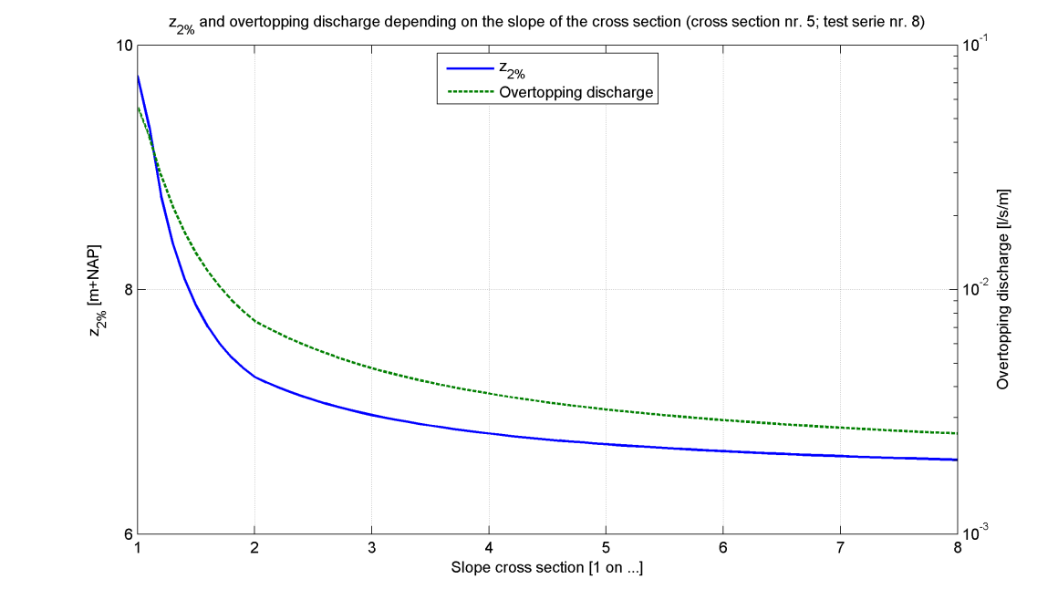

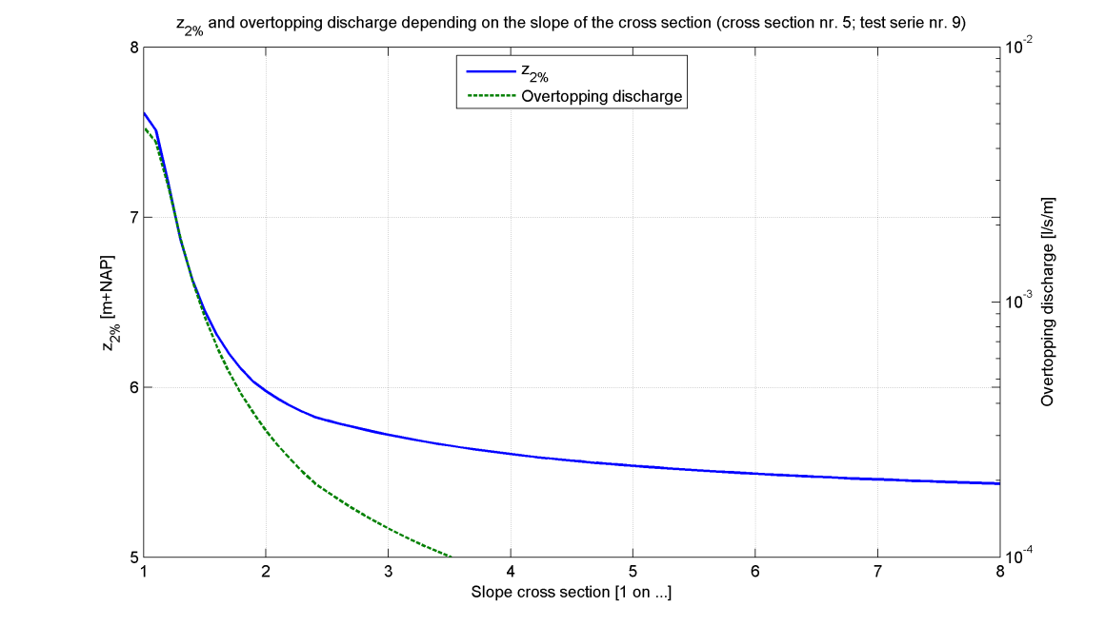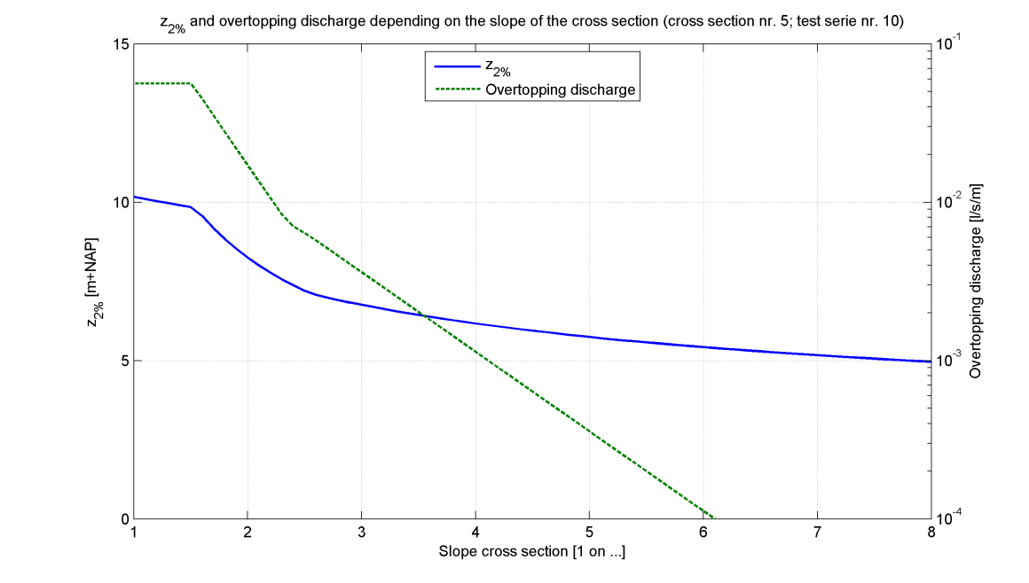

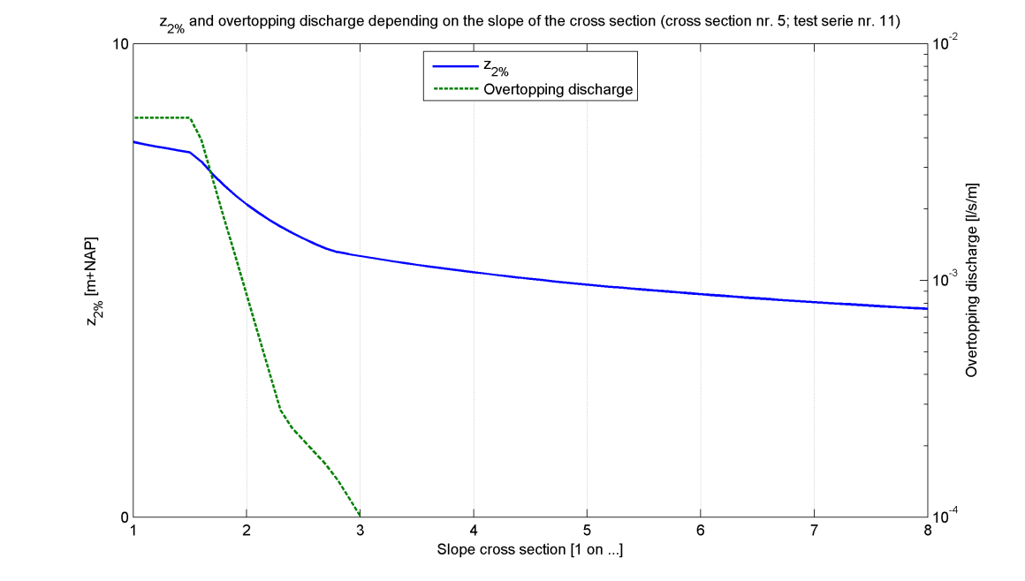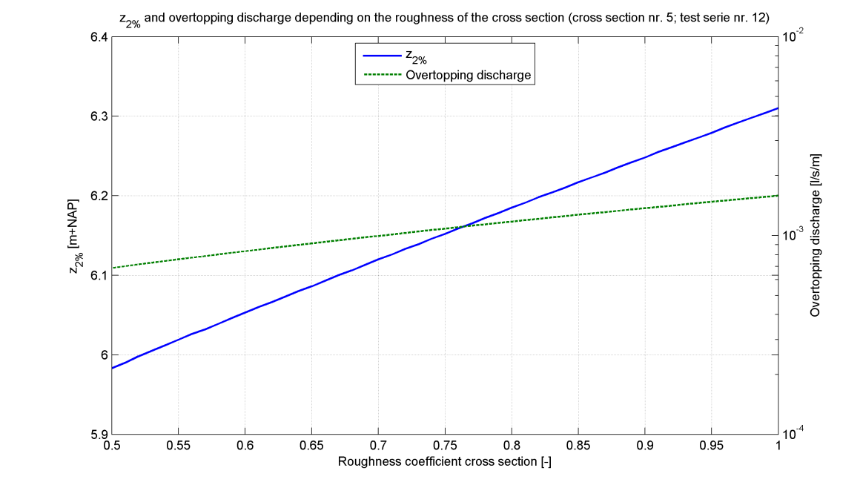

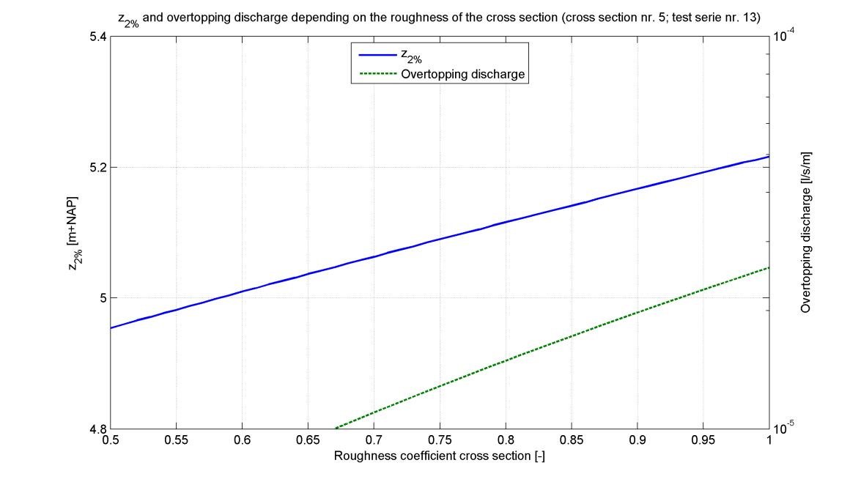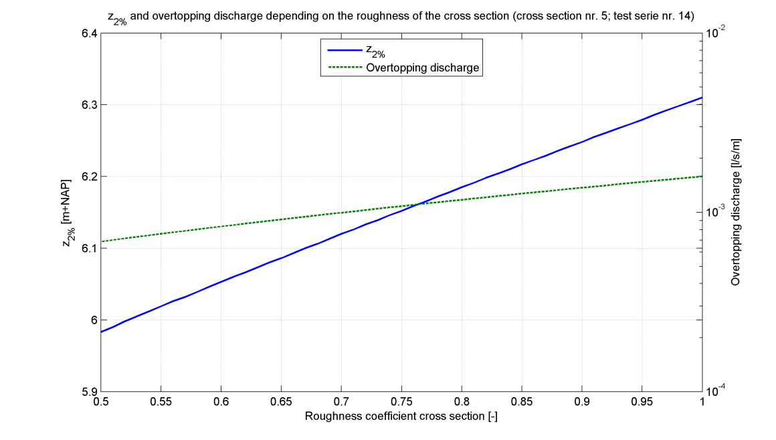

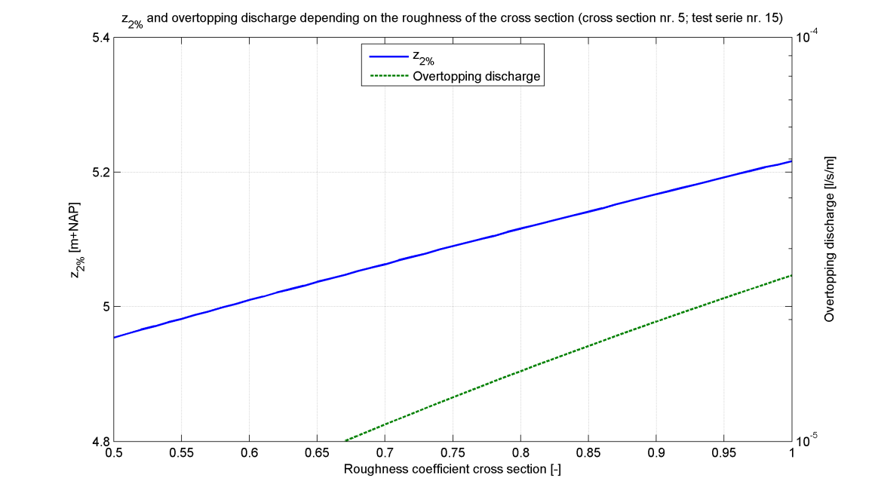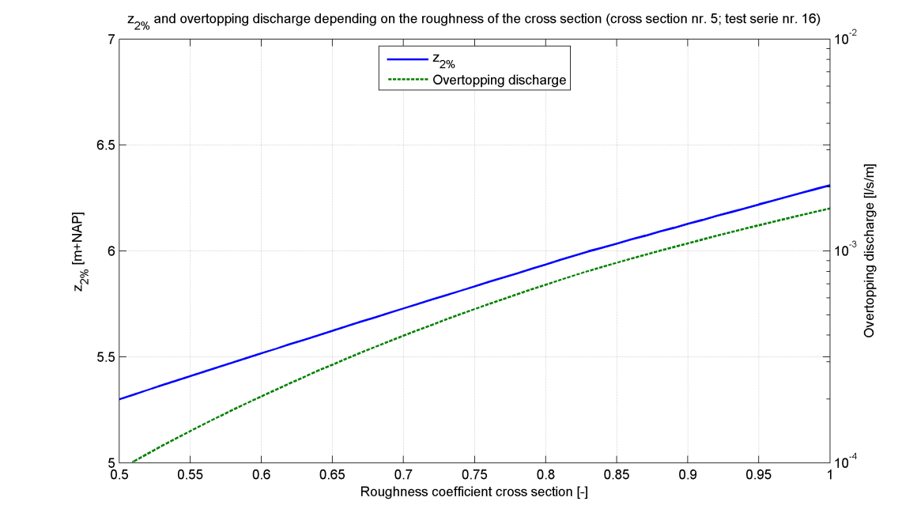

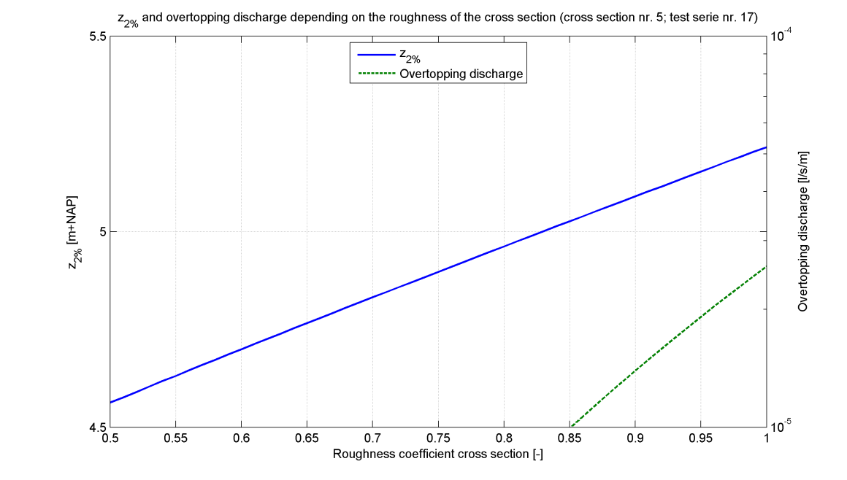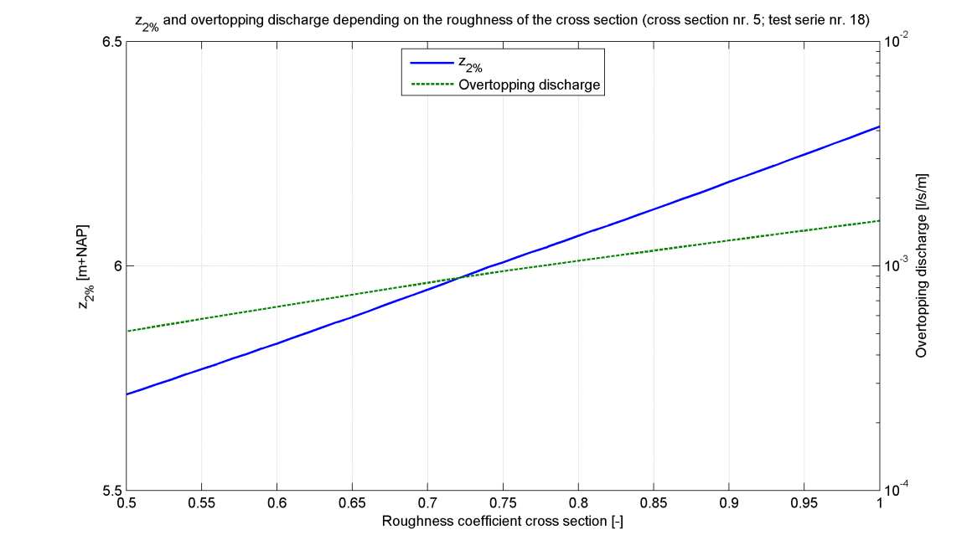

|  |
| --- |
| Cross section 5 |

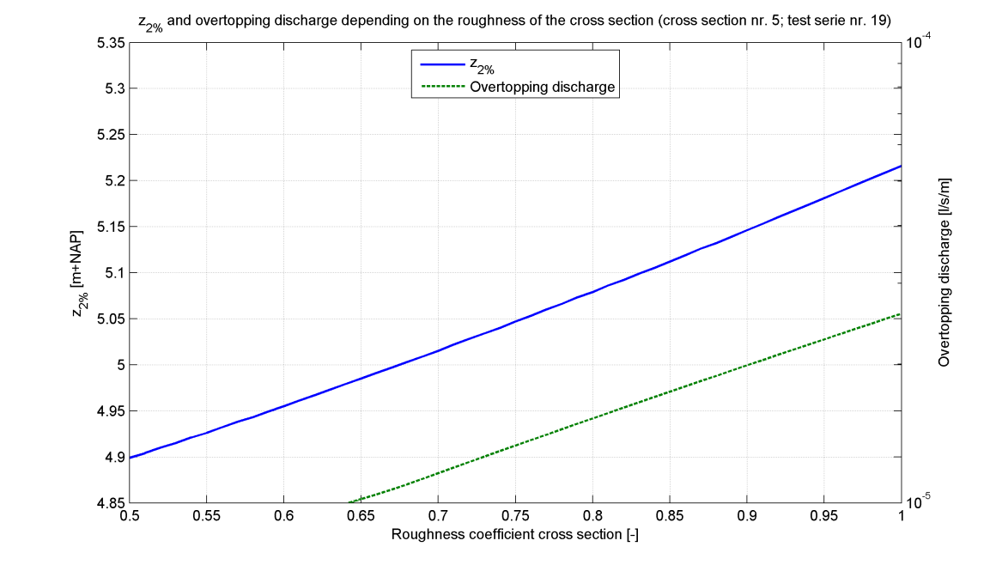

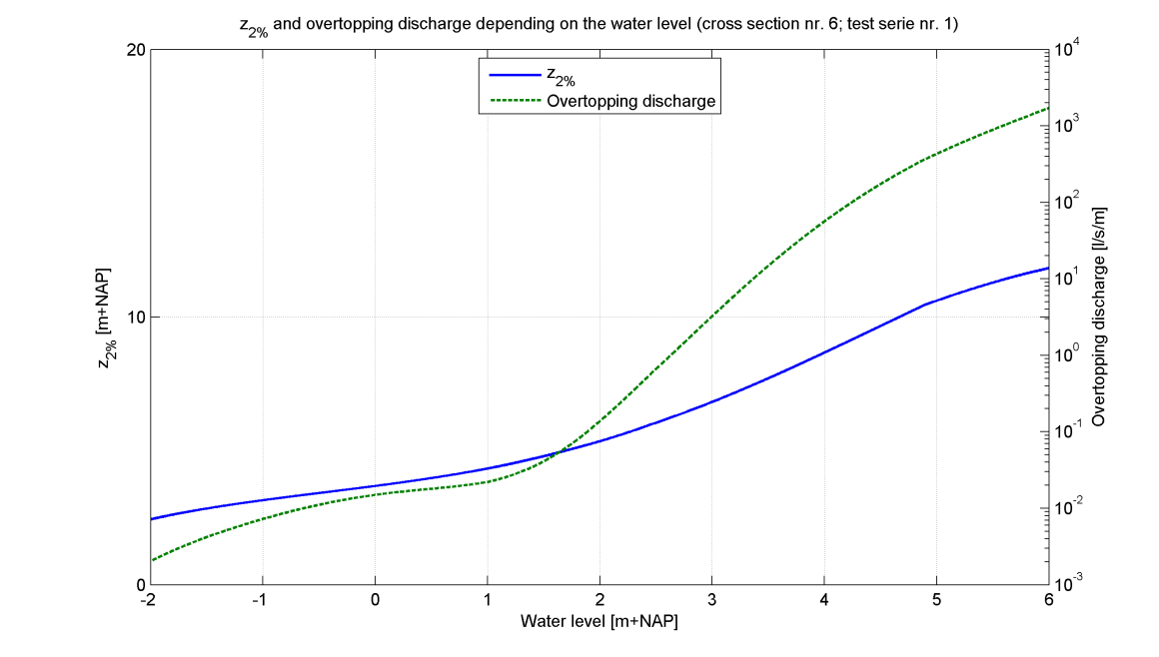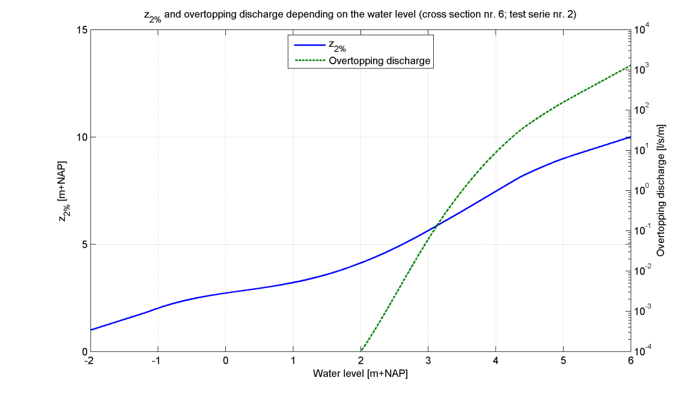

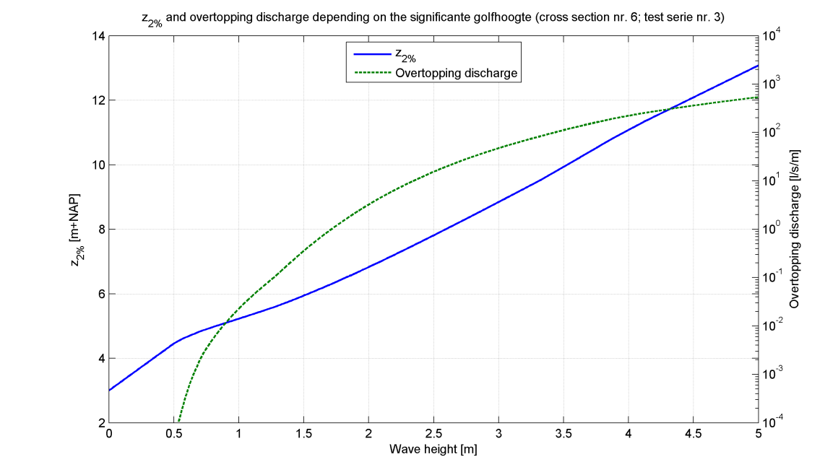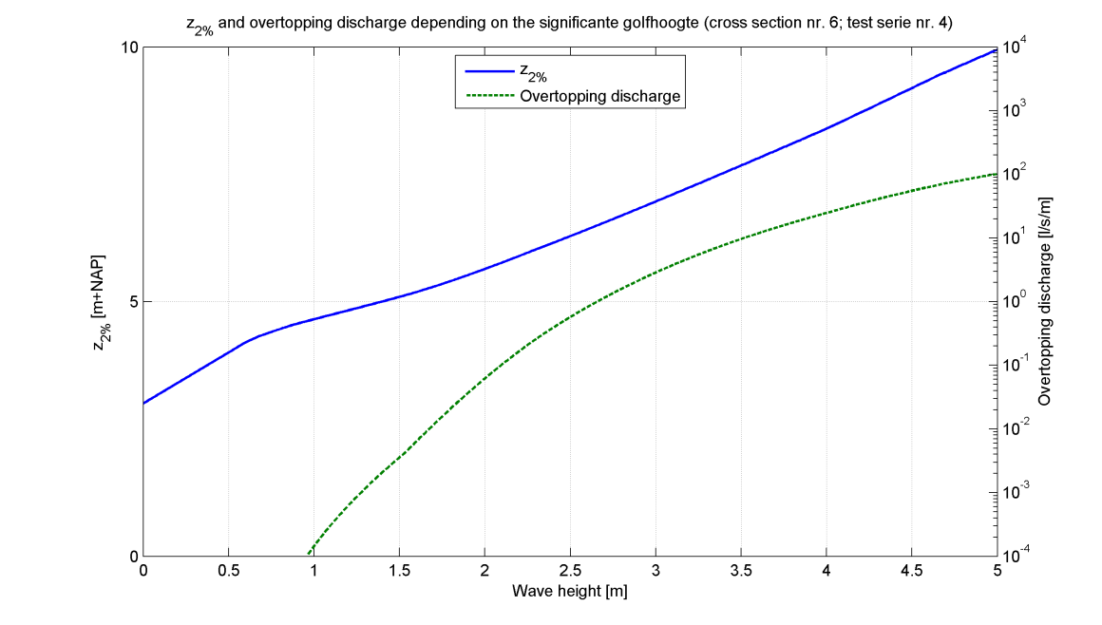

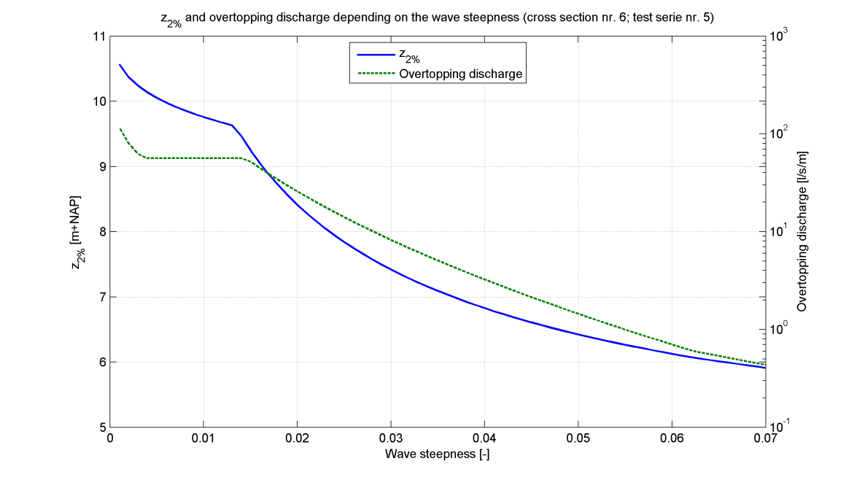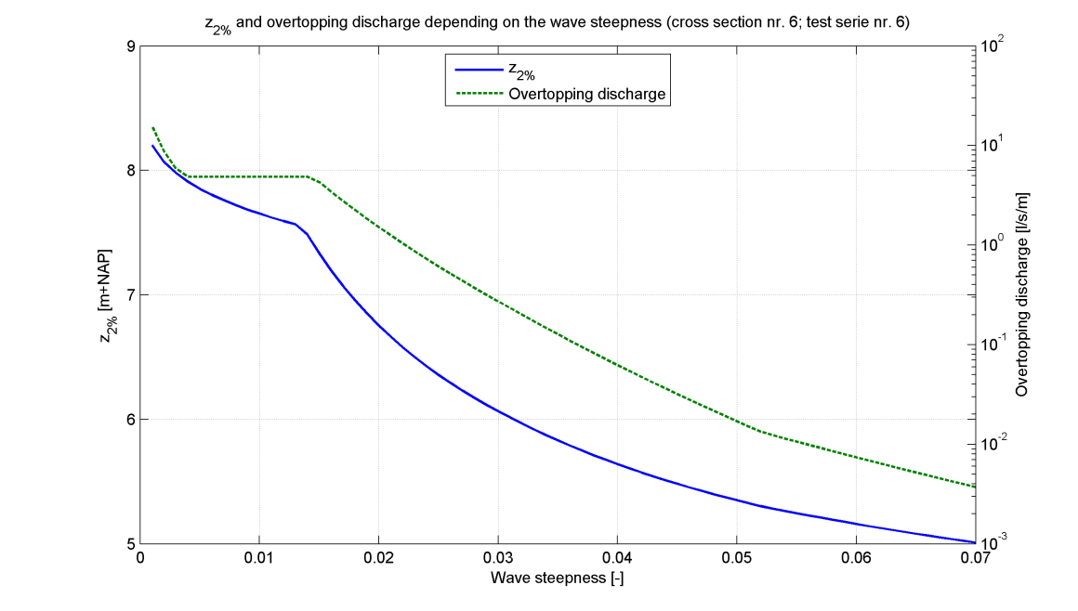

|  |
| --- |
| Cross section 6 |

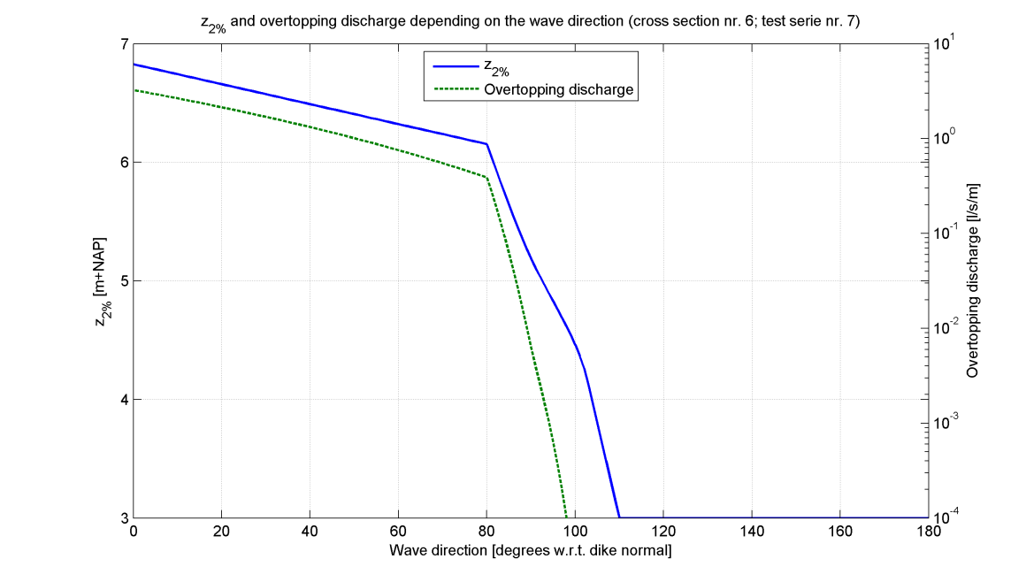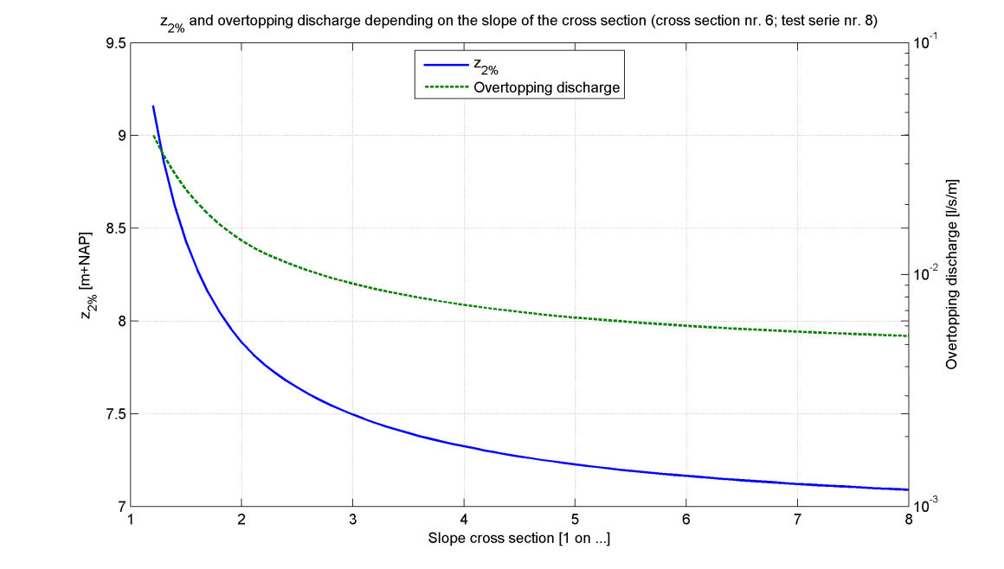

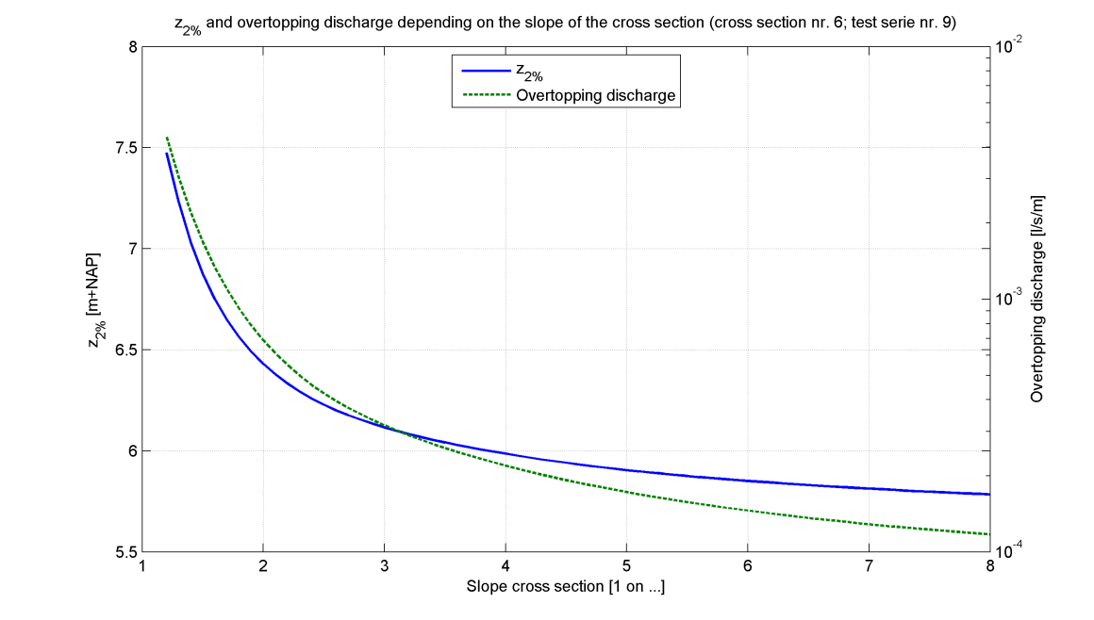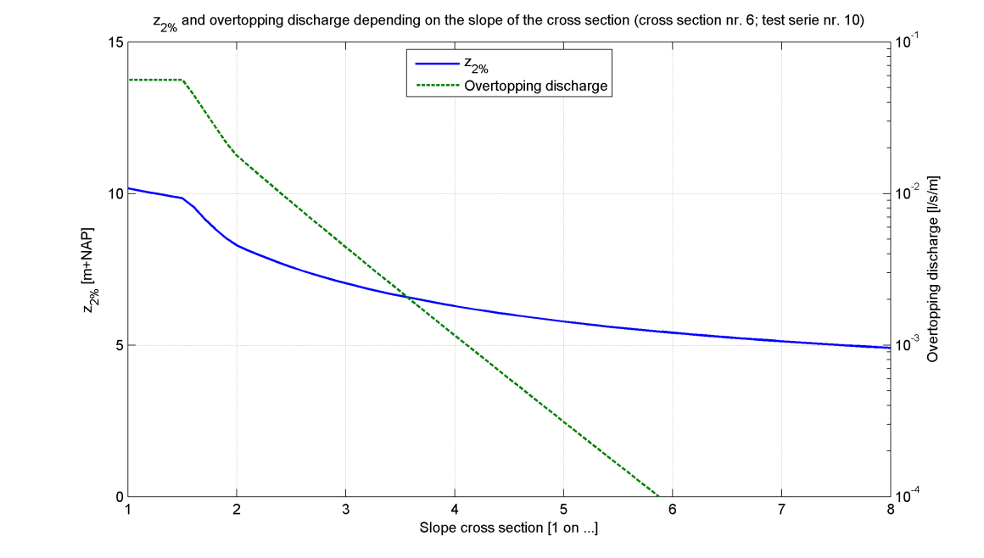

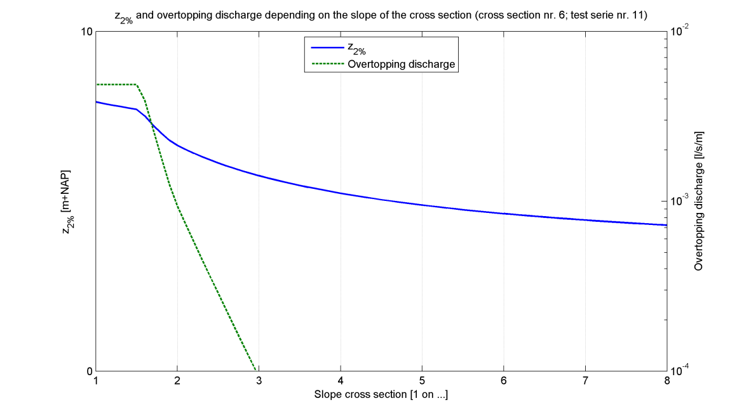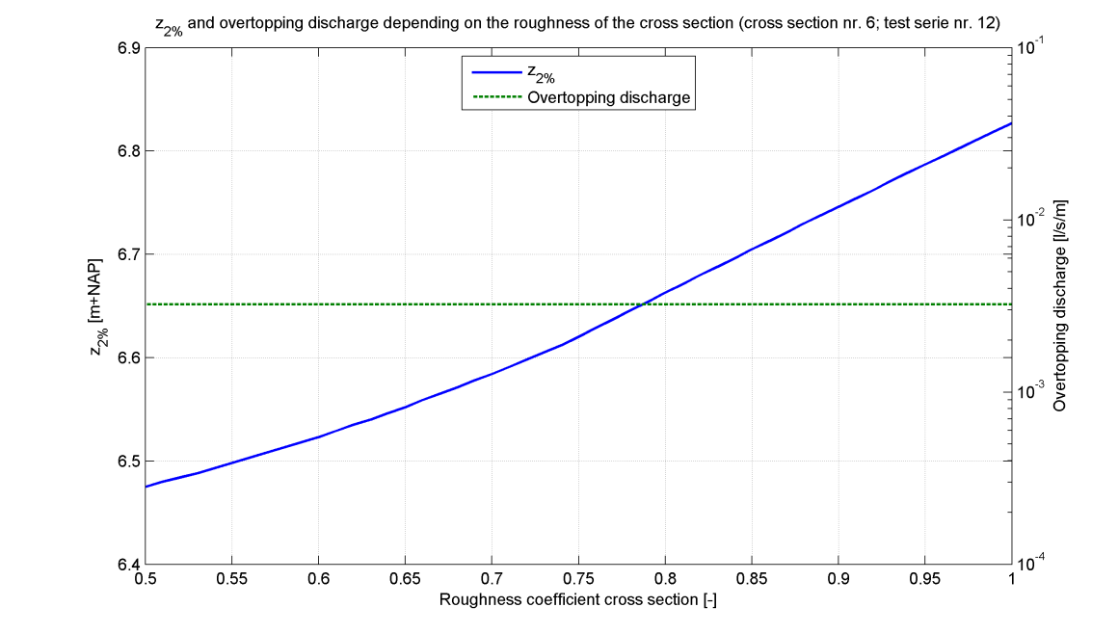

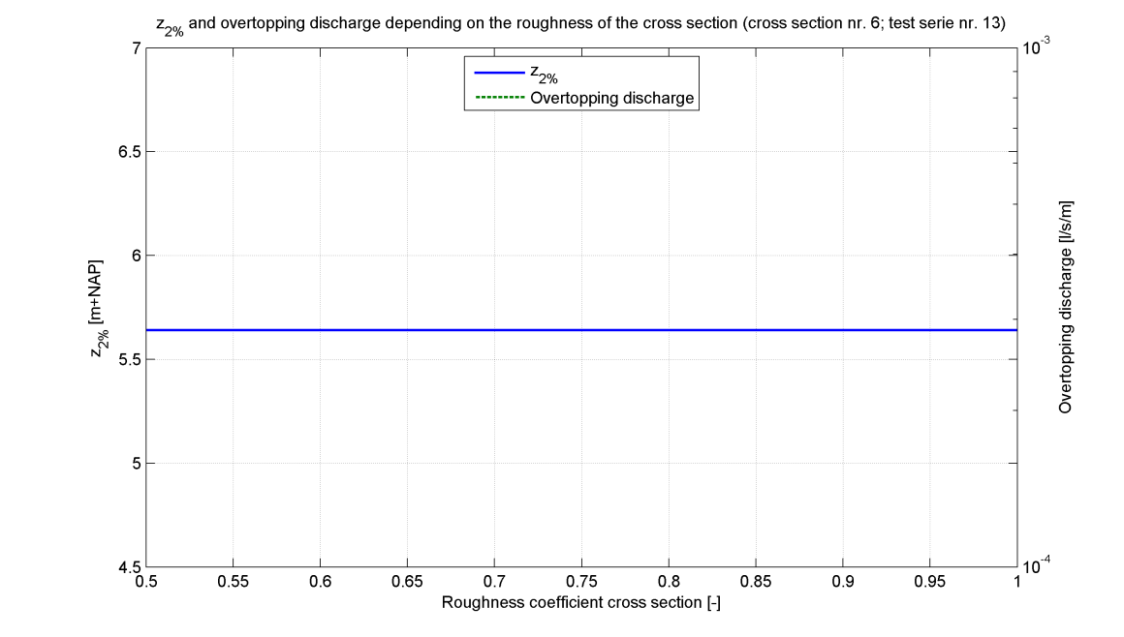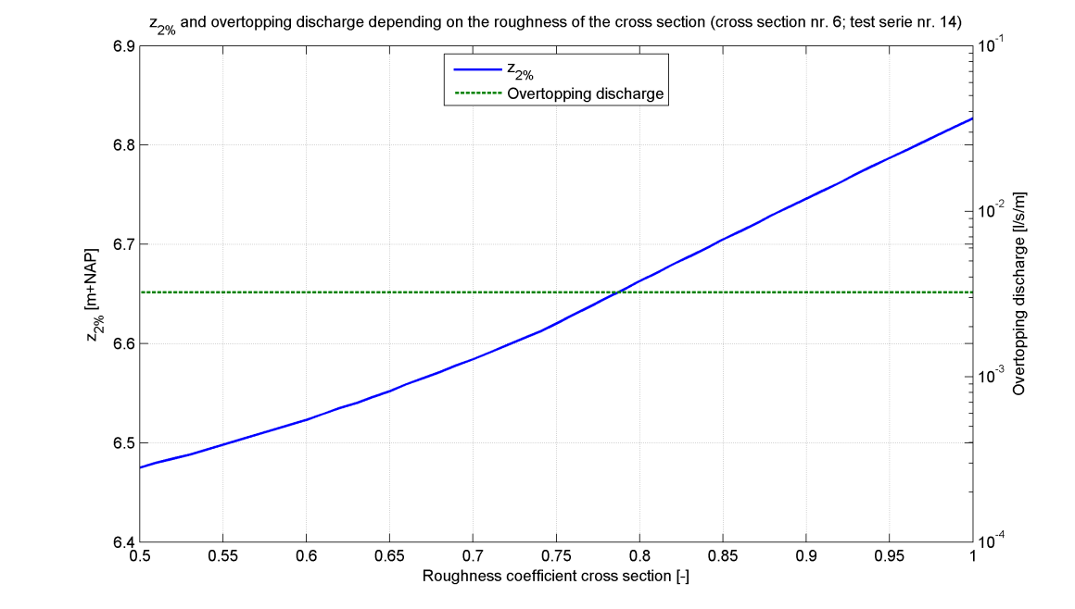

|  |
| --- |
| Cross section 6 |

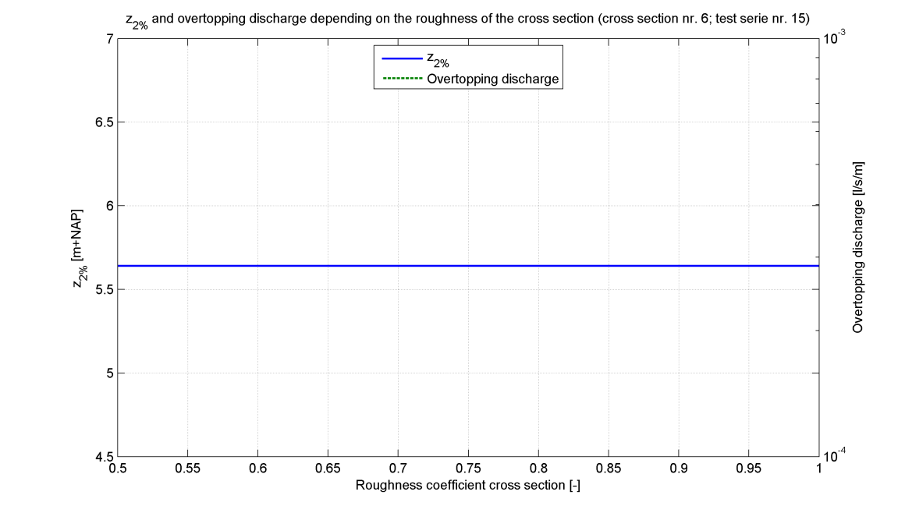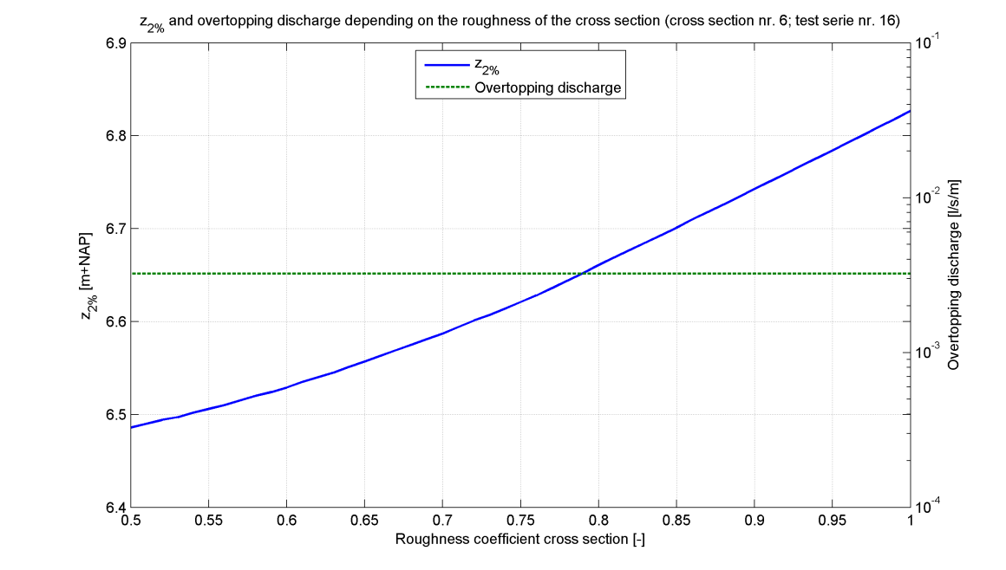

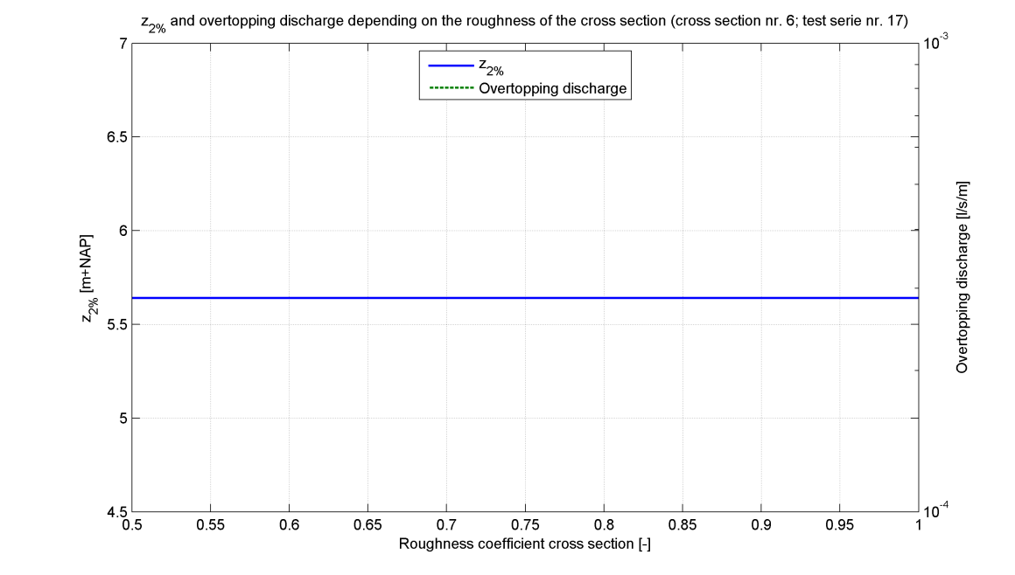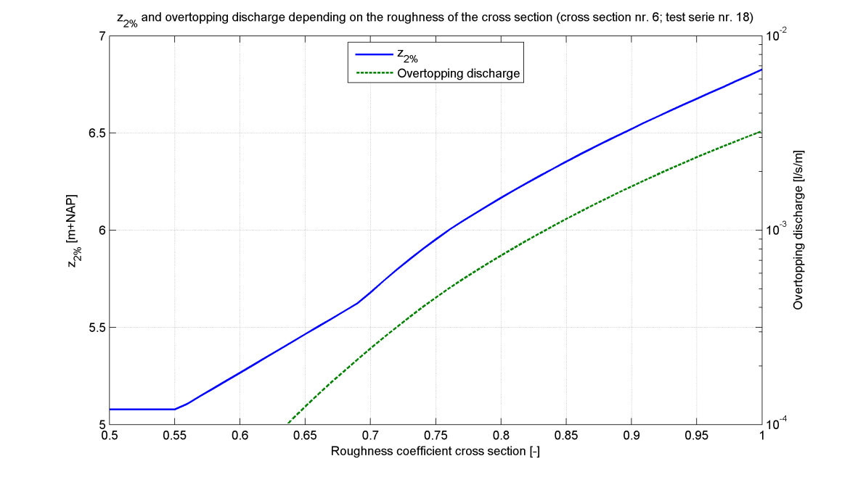

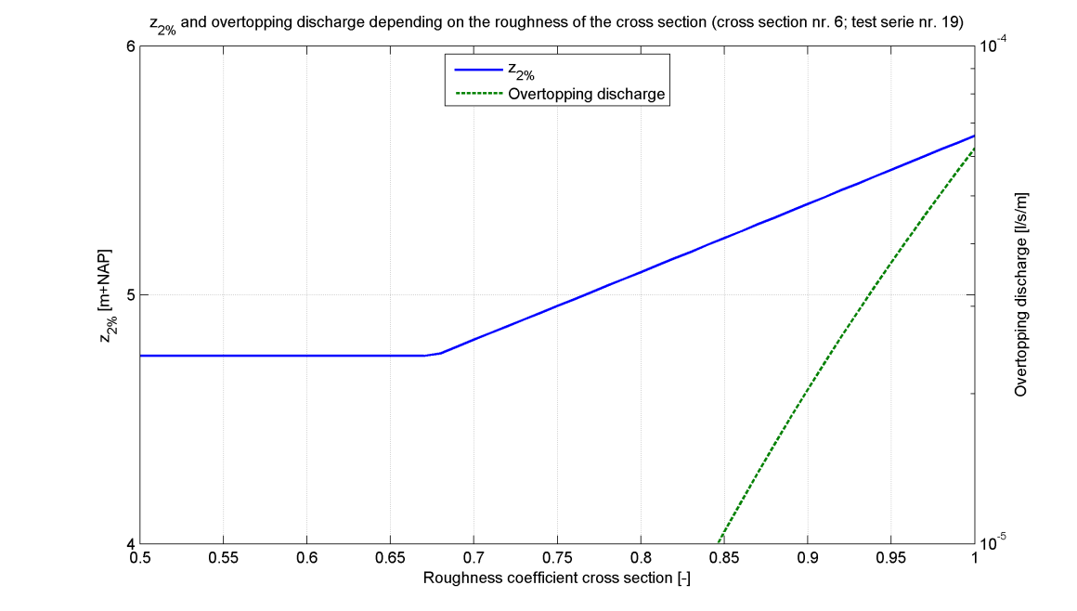

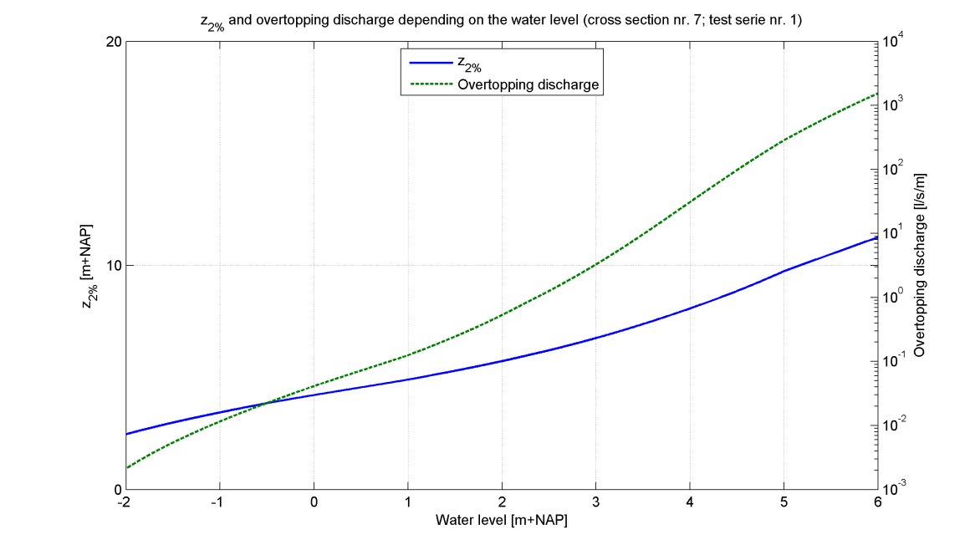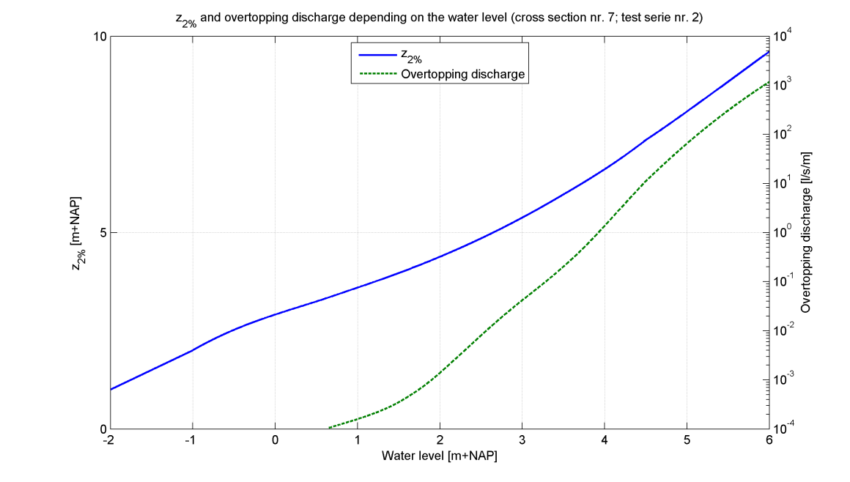

|  |
| --- |
| Cross section 7 |

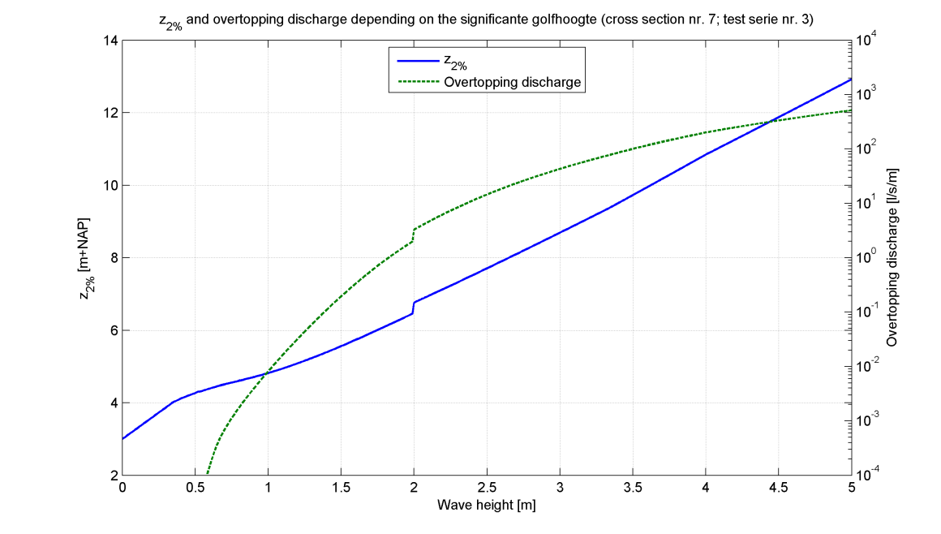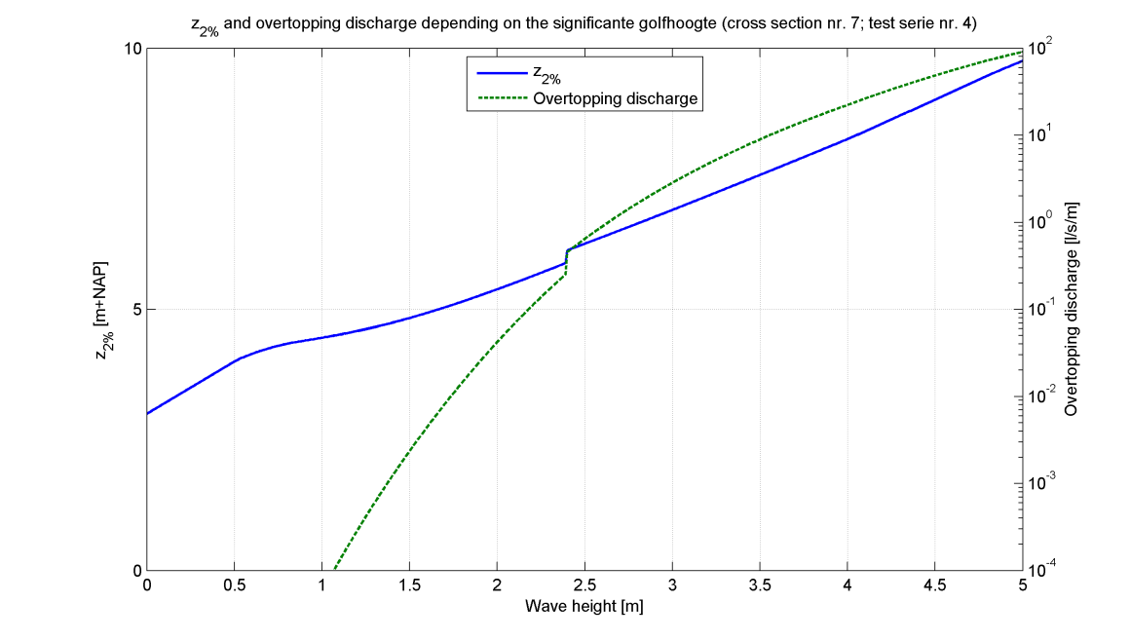

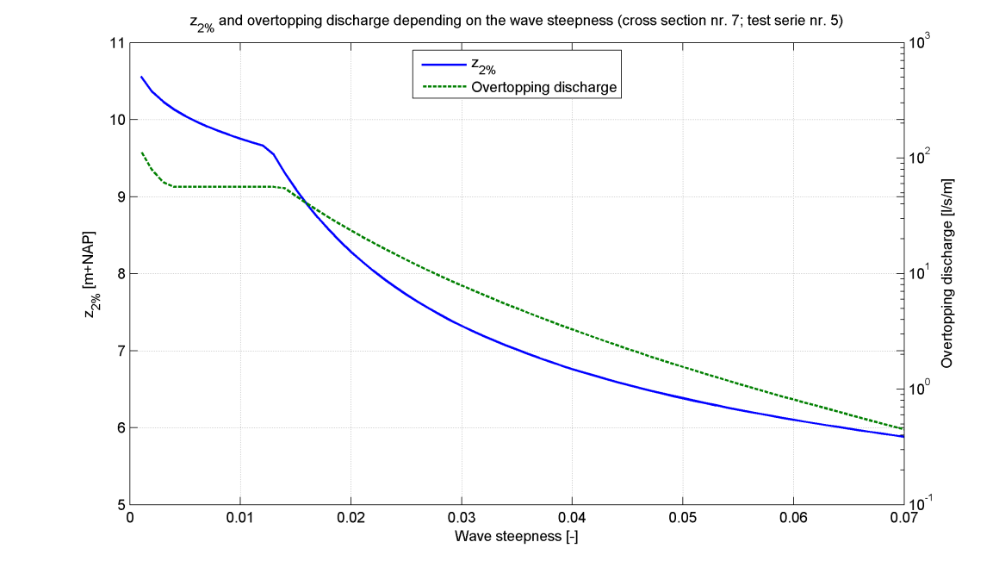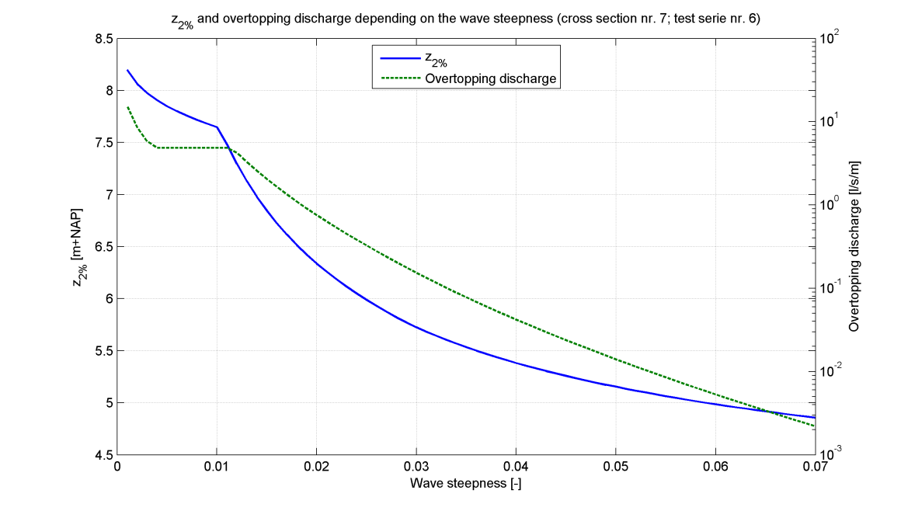

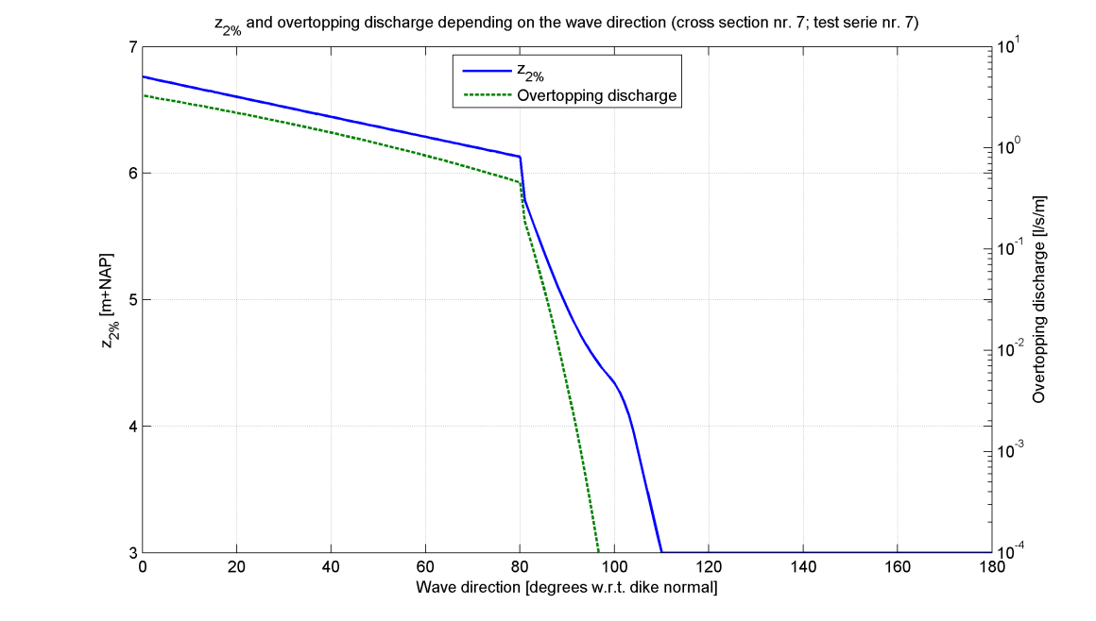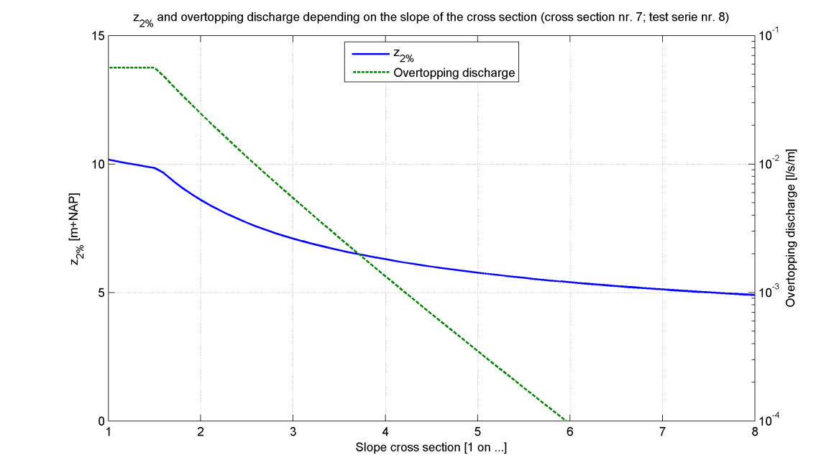

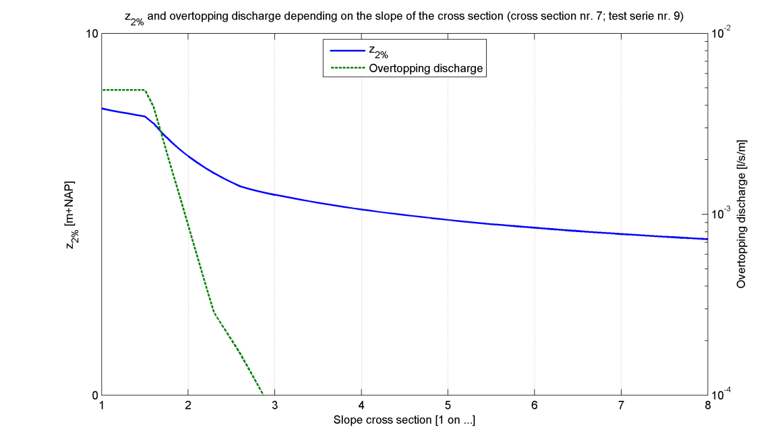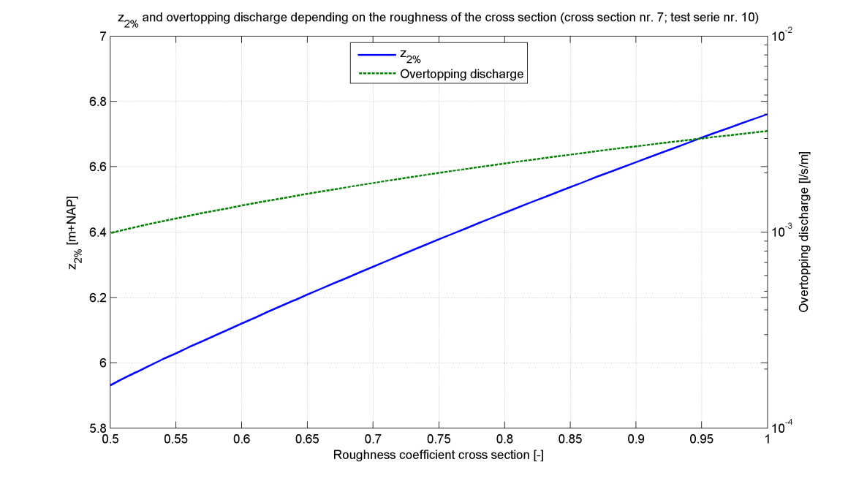

|  |
| --- |
| Cross section 7 |

